**Discovery of novel antimyeloma agents targeting trip13 by molecular modeling and bioassay**

Samuel Jacob Bunu1,3, Haiyan Cai2, Zhaoyin Zhou1, Yanlei Zhang2, Yue Lai2, Guanli Wang2, Zhijian Xu1,3, Jumei Shi2, Weiliang Zhu1,3,*

*1 State Key Laboratory of Drug Research; Drug Discovery and Design Center, Shanghai Institute of Materia Medica, Chinese Academy of Sciences, Shanghai 201203, China.*

*2 Department of Hematology, Shanghai East Hospital, Tongji University School of Medicine, Shanghai, 200120, China.*

*3 School of Pharmacy, University of Chinese Academy of Sciences, No.19A Yuquan Road, Beijing 100049, China.*

*\*Corresponding author*

**Abstract**

Thyroid hormone receptor-interacting protein-13 (TRIP13) is an AAA+ ATPase that regulates protein complex assembly and disassembly and is known to be a chromosomal instability gene, with the ability to repair DNA-double-strand breaks (DSBs). TRIP13 overexpression has been linked to the proliferation and development of many human malignancies, including multiple myeloma (MM). Accordingly, TRIP13 is recognized as a potential drug target for anticancer drug development with some reported inhibitors but none under clinical trials or approved for clinical use. This study aims to identify novel small molecules as potential TRIP13 inhibitors structural different from previously reported compounds through virtual screening, ligand-based similarity search, and different bioassays. This leads to the discovery of five compounds exhibiting high antiproliferative activities on multiple myeloma (MM) cell lines and good enzyme inhibitory properties. Among them, F368-0183 showed the best antiproliferative activity with IC50 = 5.25 μM (H-929 cell line), comparable to the positive control DCZ0415 (IC50 = 9.64 μM). Also, the cellular thermal shift assay (CETSA) confirmed that this compound could specifically target and interact with the TRIP13 protein in MM cells. In addition, the AAA+ ATPase activity assay demonstrated that the five compounds showed better inhibitory activity with DCZ0415. Further molecular dynamic simulation studies revealed that the novel compounds could significantly interact with 12 residues of TRIP13, especially, R386, E139, R389, E135, S138, and G385. Therefore, the new molecular scaffolds of these compounds, their efficacy in suppressing MM cell line proliferation, and the displayed TRIP13 AAA+ ATPase inhibitory properties provide important clues for the development of novel anti-MM drugs by targeting TRIP13.

***Keywords****: TRIP13 inhibitors, virtual screening, multiple myeloma, bioassay, MD simulation.*

**TOC**

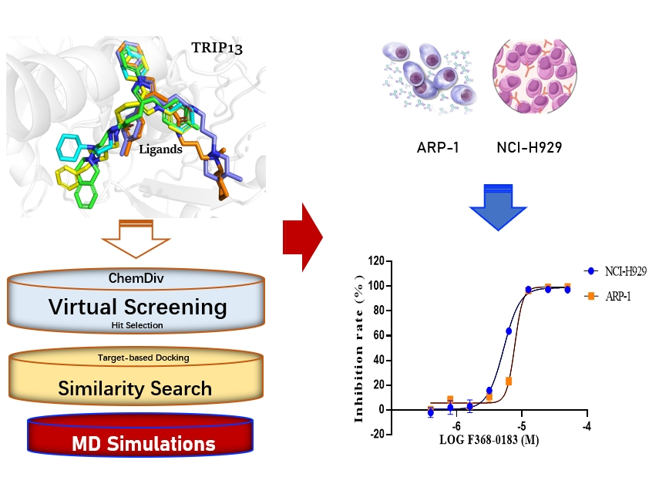

**Introduction**

The Thyroid Hormone Receptor Interacting Protein-13 (TRIP13) is an AAA+ ATPase protein superfamily member that regulates the DNA spindle assembly checkpoints (SAC) and repair pathways during mitosis.1, 2 Dysregulation of TRIP13 protein levels has been linked to several human malignancies, including breast,3 liver,4 gastric,5, 6 lung,7 prostate,8 chronic lymphocytic leukemia,9, 10 Wilms tumor,11, 12 multiple myeloma (MM),13, 14 mosaic variegated aneuploidy (MVA) syndrome and juvenile granulosa cell tumors,12, 15, 16 B-cell,17 and several other cancers and carcinomas.18, 19 TRIP13 has been reported to regulate the DNA repair pathway.20-22 Specifically, during mitosis, TRIP13 is known to modulate the SAC by changing its effector MAD2 from closed–active conformation of mitotic arrest deficient-2 (CMAD2) to open–inactive form, OMAD2.23-27 Modifications and elevated levels of TRIP13 have also been linked to treatment resistance and poor prognosis in certain human cancers and carcinomas such as bladder,28 non‑small cell lung,29 head and neck,30, 31 colorectal,32 glioblastomas,33 esophageal squamous cell carcinoma,34, 35 lung adenocarcinoma,36 MM,37 and renal cell carcinoma.38 This means that TRIP13 apart from being a potential drug target in cancer pharmacotherapy,39, 40 may also be targeted to prevent anticancer drug resistance.41

Our earlier studies found that TRIP13, a chromosomal instability gene (CING),42 is associated with treatment resistance, disease relapse, and treatment failure in MM patients.37, 43 MM is a malignant tumor of plasma-blood cells that amass in the bone marrow, causing damage and failure.44, 45 46Several biological mechanisms have been identified in previous studies regarding TRIP13 cancer proliferation of MM.17, 43, 47 The structure of TRIP13 has been extensively studied. The crystal structure of the TRIP13 mutant-type (E253Q or E253A) revealed the mechanism of substrate recognition.23 We analyzed the crystal structure of the wild-type human TRIP13 at a resolution of 2.6 Å and discovered small-molecule inhibitors of TRIP13 using molecular docking and different bioassay techniques.13 DCZ0415, the first TRIP13 small-molecule inhibitor was reported to impair the DNA repair mechanism and inhibit the NF-kB signaling pathway in MM cells. DCZ0415 binding to TRIP13 was revealed using pull-down, NMR spectroscopy, and surface plasmon response (SPR) analysis, with substantial antimyeloma action in vitro and in vivo. DCZ0415 also exhibited synergy with conventional anticancer agents like melphalan and panobinostat in suppressing MM cells, respectively.13, 48, 49

Following the identification of DCZ0415, other novel inhibitors of TRIP13 have been isolated via molecular docking strategies and synthetic routes from natural products. TI17 was discovered through a parallel compound-centric strategy and reported to substantially suppress MM cell proliferation, arrest cell cycles, and induce apoptosis. Furthermore, TI17 inhibited tumor growth by inhibiting the TRIP13 function of DSB repair and increased DNA damage responses associated with MM. A synergistic anti-MM effect was observed when melphalan or panobinostat were used in combination with TI17, respectively.50 DCZ5417 is a derivative of Norcantharidin (NCTD),51, 52 and was found to bind with TRIP13 via molecular docking, SPR analysis, pull-down, and cellular thermal shift assays.51 DCZ5417 inhibited MM cell progression by targeting TRIP13, perturbing the TRIP13/YWHAE complex, and inhibiting the ERK/MAPK signaling axis, with increased cytotoxicity when combined with melphalan and lenalidomide.51 DCZ5418 demonstrated good anti-MM activity in vitro, definite protein interaction, and was less toxic in vivo than cantharidin.14, 53 In-vivo analysis of DCZ5418 also revealed significant anti-MM activities in tumor xenograft models, with increased safety and efficacy.14 Recently, we discovered a novel 1-amido-2-one-4-thio-deoxypyranose derivative as a potential antimyeloma agent by inhibiting TRIP13 AAA+ ATPase functions.54 These studies indicated TRIP13 as a promising drug target in the treatment of different human cancers,55,56 especially MM,13 leading to the design and discovery of several TRIP13 inhibitors. However, none of the reported inhibitors is under clinical trial or being approved for actual clinical use, accordingly, novel inhibitors with new scaffolds (different from the reported compounds), highly potent bioactivity, and good druggability properties are expected to unravel new alternatives in cancer pharmacotherapy, including MM.40

We, searched the updated ChemDiv database (2023 version),57 with over 1.6 million small organic molecules, and identified some small molecule inhibitors of TRIP13 using virtual screening, molecular docking, SPR analysis, antiproliferative bioassay, cellular thermal shift assay (CETSA) and molecular dynamic simulations, showed good antimyeloma effects in-vitro using MM cell lines.

1. **Materials and methods**
   1. ***Virtual screening and molecular docking***

The TRIP13 protein crystal structure downloaded from the RCSB Protein data bank (PDB ID: 6LK0) was used for the in-silico studies. Virtual screening was performed with Glide from Schrodinger 2020,58 using the ChemDiv database with over 1.6 million small organic molecules. Those compounds with good protein-ligand docking scores were procured from the vendor (Topscience Co. Ltd). To estimate the binding affinities and modes between the molecules and TRIP13 protein, Glide from Schrodinger , was used with docking parameters, 24.45 (x), 14.91 (y), and 10.54 (z) coordinates and 30,30,30 diameter box size.59, 60 The ATP binding pockets of the human TRIP13 protein (PDB ID: 5VQA)23 were utilized in 6LK0 following successful alignment with the Schrodinger suit.

* 1. ***Ligand-based similarity search***

A ligand-based similarity search was conducted on the hit compound, F368-0090. The hit compound (F368-0090) consists of a pyrazole ring with phenyl (position 1) and para-methyl-phenyl (position 3), a propanamide moiety (position 4), and an N-substituent on the amide nitrogen with a piperidin-1-yl group. The similarity search was based on the whole molecular scaffold of F368-0090 (3-[3-(4-methylphenyl)-1-phenyl-1h-pyrazol-4-yl]-n-[2-(piperidin-1-yl)-ethyl]-propanamide) using 0.8 similarity index in the ChemDiv database.

* 1. ***Molecular dynamics simulations***

A Molecular dynamic (MD) simulation was performed on the TRIP13-ligand complexes to explore the binding differences with TRIP13 between active and inactive compounds. MD simulation is a powerful computational approach used in drug design to study ligand-protein dynamic behaviors and calculate thermodynamic parameters using the physical movements of atoms and molecules over time.61-63 The 3D structure of wild-type TRIP13 was retrieved from the protein data bank (PDB ID: 6LK0). Gaussian 16 B.012 was used to optimize the structure of all the ligands and calculate their electrostatic potential at the B3LYP/6-31G* level, then the atomic partial charges were obtained via the restrained electrostatic potential (RESP) approach using an antechamber module of AmberTools. Protonation states of complexes were assessed using PDB2PQR at pH 7.4. These systems were solvated using the OPC model and neutralized by Na+. Proteins and ligands were parametrized using AMBER ff19SB an7*+/d GAFF2 force fields. Energy minimization was performed using the steepest descent minimization algorithm with a maximum of 50,000 steps. The systems were equilibrated for 100 ps at 300 K for the NVT ensemble, followed by 100 ns NPT with the Parrinello-Rahman coupling for the pressure of 1 bar. GROMACS 2022.5 software package was used to run the minimization, and equilibration simulations with position constraints on both the protein and the ligand, and perform the 200 ns MD simulations in triplicate at 300 K utilizing the mdrun module, 1 bar for all complexes.64 Temperature and pressure were controlled by a V-rescale thermostat and a C-rescale barostat. Bonds involving hydrogen atoms were fixed by the SHAKE algorithm. The binding free energy (ΔG) of all the complexes was calculated by the MM/GBSA method using the GB OBC model (igb = 5) with a salt concentration of 150 mM. Trajectories spanning from 0-200 ns were used for ΔG calculation (1000 snapshots for each run).

* 1. ***Free energy perturbation calculation***

Hermite Uni-FEP (https://hermite.dp.tech/) was employed to perform free energy perturbation (FEP) calculations. The wild-type TRIP13 protein (PDB ID: 6LK0) was used as the receptor. Using the position of ATP in the human TRIP13-ATP complex (PDB ID: 5VQA) as a reference, five ligands were docked to the ATP-binding site via constrained docking, and these configurations were used as the initial structures to construct a perturbation map. GROMACS 202165 was utilized as the simulation medium, with AMBER99SB-ILDN force field applied for the protein and the GAFF2 for ligands. Additionally, the REST266 method was employed to ensure thorough sampling and accurate estimation of binding free energy. Each perturbation pair underwent a 5 ns simulation with 16 intermediate λ windows.

* 1. ***Cell lines and reagents***

The NCI-H929 and ARP-1 cell lines were maintained in RPMI 1640 medium (Gibco, Carlsbad, CA, USA), supplemented with 10% fetal bovine serum (FBS; VivaCell, Shanghai, China). All cells were cultured in a humidified atmosphere incubator with 5% CO2 at 37℃. Cell Counting Kit-8 (CCK-8) was from Beyotime (China), whileTRIP13 antibody was purchased from Proteintech (Wuhan, China).

* 1. ***In-vitro anti-proliferative assay***

The cell viability or growth inhibitory effect of compounds on MM cell lines (ARP-1 and NCI-H929) was assessed using the CCK-8 assays as previously described.51 The MM cell lines were plated at a density of 2×105 cells/mL in a 96-well plate. The cells were treated by test compounds for 72 hr in triplicate. Then CCK8 reagent was added. After incubation for another 2 h at 37℃, the absorbance of the reaction mixture was measured at 450 nm. The inhibition induced by each test compound was expressed as a percentage and the half-maximal inhibition concentration (IC50) was calculated using the GraphPad Prism software.

* 1. ***TRIP13 protein purification***

TRIP13 protein was expressed and purified as described in previous research.51 TRIP13 protein was expressed in *E. coli* at 16 °C for 20 h. The collected cells were completely lysed in a lysis buffer through ultrasound (50 mM Tris–HCl, pH 7.5, 500 mM NaCl, 10% glycerol). The supernatant was subjected to Ni2+-affinity purification, followed by tag cleavage. The resulting fraction was further purified by protein chromatography and ion exchange columns to obtain high-purity protein. Sample purity was confirmed as high as 95% based on protein peak positions by SDS-PAGE analysis and Coomassie staining. The target protein was collected, concentrated, and stored at -80°C.

* 1. ***Surface plasmon resonance analysis***

Surface plasmon resonance (SPR) assay was conducted as described in our previous research.67 SPR analysis is a useful technique for determining the affinity and specificity of biomolecular interactions.68, 69 It can also estimate the association and dissociation rate constants, simulate biomolecular interaction kinetics, investigate equilibrium binding and ligand specificity to potential biological targets [74, 75], and perform therapeutic drug monitoring.70 TRIP13 protein was dissolved in Phosphate Buffered Saline (PBS) at pH 7.4 and then 200 µg/mL protein was immobilized on a CM5 sensor chip until 20000 RU was reached. Subsequently, the tested compound was diluted with a PBS buffer using two-fold dilution steps, to give a range of concentration gradients between (0.049-25 μM). Binding Kinetics of the hit compound (F368-0090) was recorded at 25 ℃ on the BiacoreTM 8K instrument (Cytiva), and affinity (KD), association rate constant (ka), and dissociation rate constant (kd) were calculated using a 1:1 interaction model via BiacoreTM 8K evaluation software (Cytiva), respectively.

* 1. ***TRIP13 AAA+ ATPase inhibitory assay***

TRIP13 AAA+ ATPase assay was employed to determine the relative inhibitory activity of the tested compounds on TRIP13 as previously mentioned.51 The purified protein was diluted to a final concentration of 1 μM using buffer containing 25 mM Tris–HCl pH 7.5, 200 mM NaCl, 20 mM MgCl2, 1 mM DTT, 5% glycerol, and 0.05% Tween. A mixture containing TRIP13 protein and different concentrations of tested compounds was pre-incubated for 30 min at 37 °C. Subsequently, ATPase assays were carried out according to the ATPase assay kit manufacturer’s protocol (Promega). The ATPase inhibitory assay was conducted in all five novel TRIP13 inhibitors obtained in the study with positive and negative control compounds.

* 1. ***Cellular thermal shift assay (CETSA)***

The cellular thermal shift assay (CETSA) was done following the previous report.71 Briefly, cell lysates from NCI-H929 cells were incubated in the presence or absence of 100 μM test compound (PBS with 0.1%DMSO as a control) for 3h and heated at different temperatures (37°C-61°C) for 3 min. All heated samples were centrifuged at 20,000 g for 20 min at 4°C. The supernatants were subjected to SDS-PAGE and western blot analysis.

* 1. ***Statistical data analysis***

GraphPad Prism and Microsoft Excel Spreadsheet software were used for statistical analysis. Data are expressed as means ± SD. Data were considered statistically significant with a P-value < 0.05 (*p < 0.05; **p < 0.01; ***p < 0.005; ****p <0.001), and not statistically significant with a P-value ≥ 0.05 (NS). The student *t*-test or ANOVA was used to assess the means of two test groups. The log-ranked test analyzed the inhibitory curves, and the median dose-effect analysis was used to generate the median concentration (IC50) values. All statistical test significance was two-sided.

1. **Results and Discussion** 
   1. ***Hit discovery by virtual screening***

Fig. 1 depicts the virtual screening process (**Fig. 1A-C**). Among the virtually identified 18 molecules with good protein-ligand binding scores, nine available compounds (Fig. 1D, **Table S1†**) were evaluated for antiproliferative activity against human multiple myeloma (MM) cell lines, NCI-H929, and ARP-1. Two of these compounds, F368-0090 and D264-1047, showed good inhibition activities on these cell lines at the concentration of 25 μM (**Table S2†**). F368-0090 showed the best cell viability inhibition of NCI-H929 and ARP-1 with IC50 values of 21.16 μM and 8.08 μM, respectively, and good solubility over D264-1047, hence it was selected for further studies. The percentage inhibition of the hit compound, F368-0090 was also compared with the standard control DCZ0415, which revealed that the compound could inhibit the catalytic function of TRIP13 (**Fig. 2A).** We then used the surface plasmon resonance (SPR) analysis to confirm that the hit compound, F368-0090 could inhibit MM cell growth by targeting and binding to TRIP13. The binding of F368-0090 to TRIP13 protein assessment with SPR analysis showed a KD value of 56.2 μM, indicating that the compound could interact with TRP13 (**Fig. 2B**).

To discover more active compounds, we conducted a ligand-based similarity search and obtained 103 similar compounds with closely related structural properties and scaffolds to the hit compound, F368-0090.

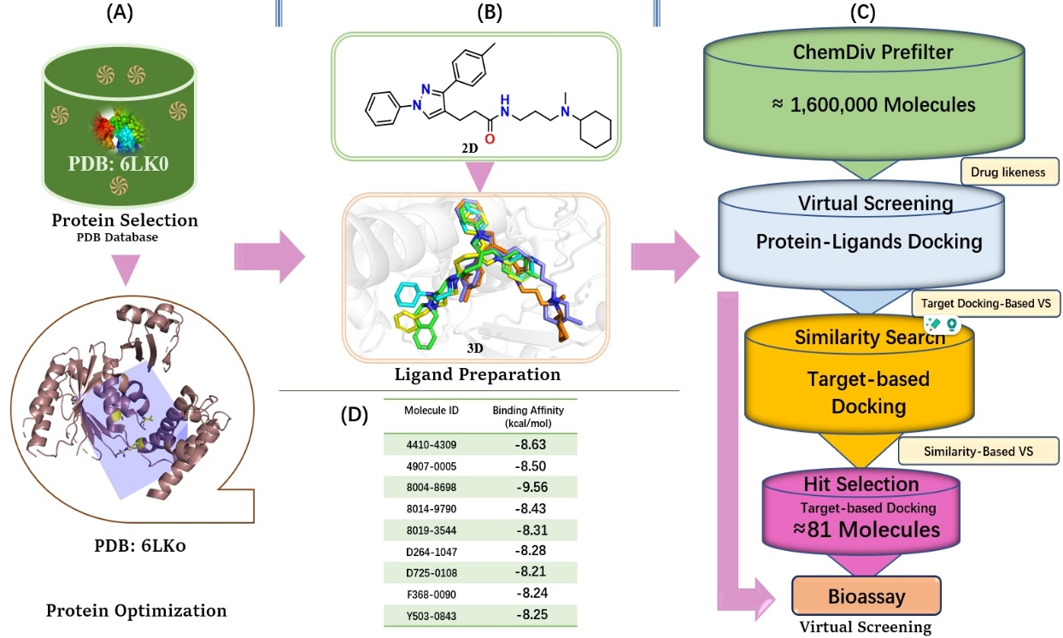

***Fig. 1 Virtual screening and hit discovery.***

**A:** Protein preparation. The purple color represents the grid box, while the yellow represents the ATP-binding pocket; **B:** Ligand preparation; **C:** Virtual screening flow chart; **D:** Active compounds with predicted binding affinity (docking scores).

* 1. ***Binding mechanism analysis between F368-0090 and TRIP13***

The hit compound, F368-0090 was confirmed to bind to the TRIP13 protein revealed via SPR analysis which prompted the similarity search and further bioassay. The molecular docking of F368-0090 with TRIP13 showed several interactions, including a hydrogen interaction between the amide carbonyl functional group (C=O) and SER-187 (**Fig. 2C**, **Fig. S1†**), a pi-cation interaction between the benzene ring of F368-0090 and ARG-386, as well as polar (THR-186, SER-138, SER-SER-187, THR-186, THR-183, and HID-133) and hydrophobic (VAL-140, LEU-139, TYR-141, ILE-330, PRO-322, PHE-132, and LEU-135) interactions. This gave some clues on the essential nature of the amide (C=O), and the benzene ring in the F368-0090 scaffold (**Fig. S2†**). Based on the binding mechanism of F368-0090, the whole molecular scaffold was preserved and used for ligand-based similarity search on the ChemDiv database.

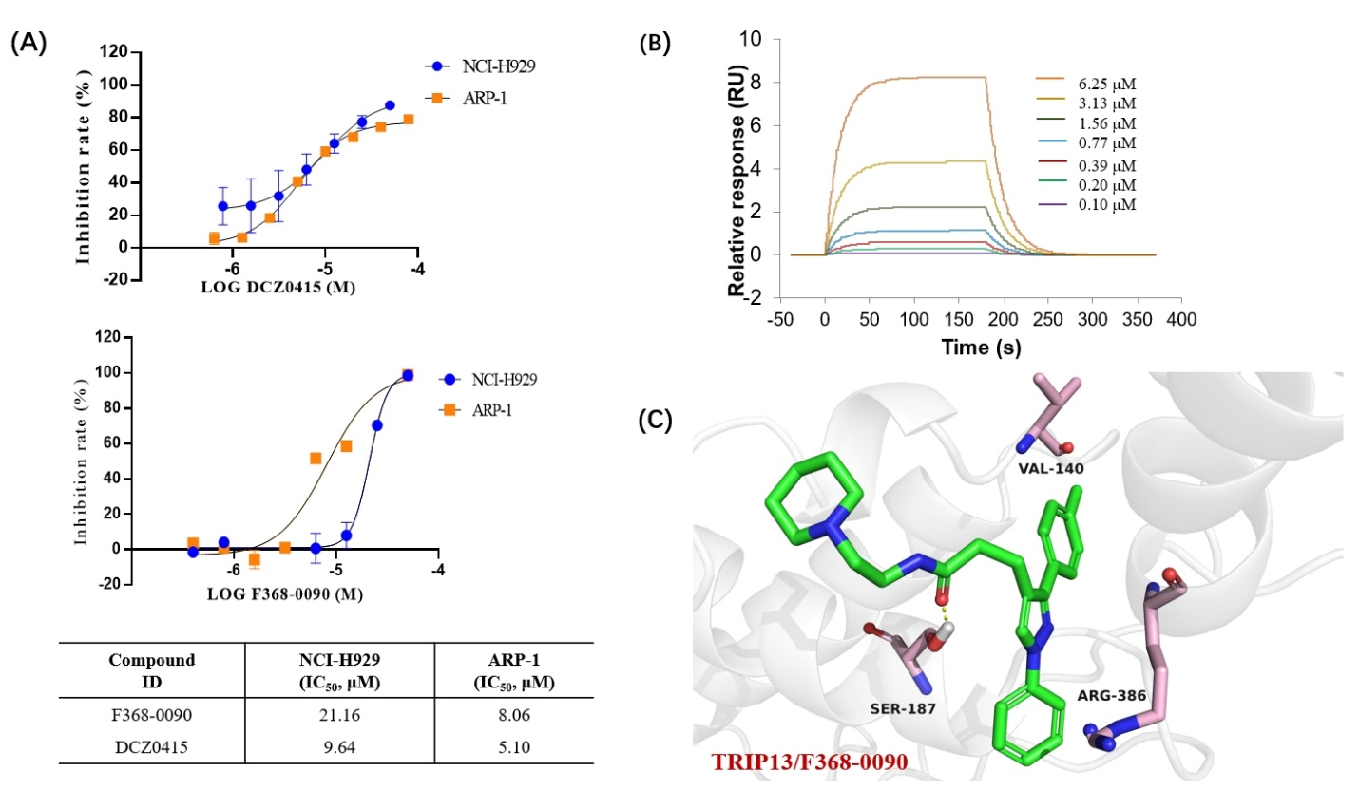

***Fig. 2 F368-0090 cell activity and SPR Assays.***

**A:** Antiproliferative activity and IC50 of hit compound F368-0090 and DCZ0415 (control) on myeloma cell lines (NCI-H929 and ARP-1); **B:** Surface Plasmon Resonance (SPR) Analysis of F368-0090 with a KD of 56.2 µM; **C:** Binding interaction of F368-0090 and TRIP13.

* 1. ***Biological evaluation and discovery of new hits***

Of 103 identified similar compounds from the ligand-based similarity search, 81 were obtained for further bioassay studies (**Table S3†**). The antiproliferative properties of these compounds were tested in vitro using NCI-H929, and ARP-1 MM cell lines at 25 μM for the first round of screening. The compounds with an inhibition rate above 50% were selected for further antiproliferative activity determination at 10 μM and 5 μM, respectively (**Fig. 3A**). The best 5 compounds (F368-0168, F368-0182, F368-0183, F368-0185, and F368-0188) showed promising antiproliferative activities with IC50 values ranging from 5.25 μM to 14.02 μM against NCI-H929, and ARP-1 MM cell lines (**Fig. 3B, Table S4†**). Among them, F368-0183 showed the highest antiproliferative activity on both H-929 and ARP-1 MM cell lines, with IC50 of 5.25 µM and 7.78 µM respectively.

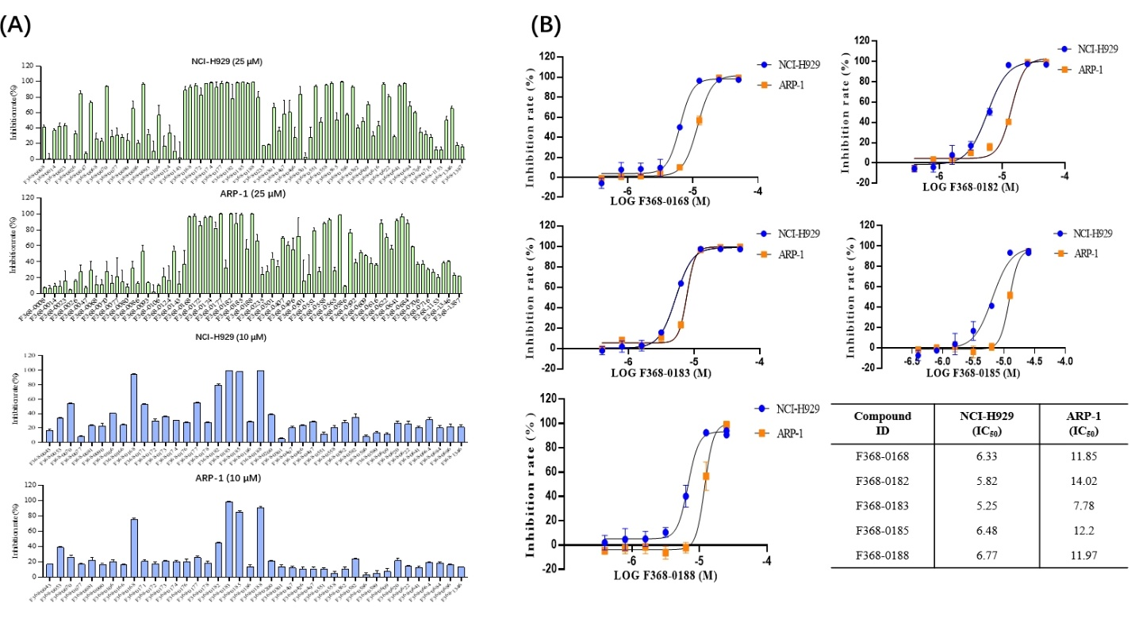

***Fig. 3 Antiproliferative assay and IC50 determination.* A:** Cell line activity of similarity-based virtually screened compounds at 25 and 10 µM, using H-929 and ARP-1 MM cell lines: **B:** IC50 of the five compounds with the best antiproliferative bioactivity and positive control.

Because TRIP13 is a member of the AAA+ ATPase protein family,72, 73 we evaluated the AAA+ ATPase inhibition potency of the hit compound (F368-0090) along with the five compounds that showed good antiproliferative activities as well as the positive control compound, DCZ0415. The result demonstrated that F368-0090 possessed a better TRIP13 AAA+ ATPase inhibitory activity than DCZ0415. Good AAA+ ATPase binding inhibition activities were observed from all five active compounds at 150 µM. F368-0188 showed the best AAA+ ATPase inhibitory activity at 150 µM followed by F368-0182 and F368-0168 respectively. The other two compounds (F368-183 and F368-0185) also showed less but comparable AAA+ ATPase inhibitory properties with the standard control (DCZ0415) and hit compound (F368-0090) (**Fig. 4A**).

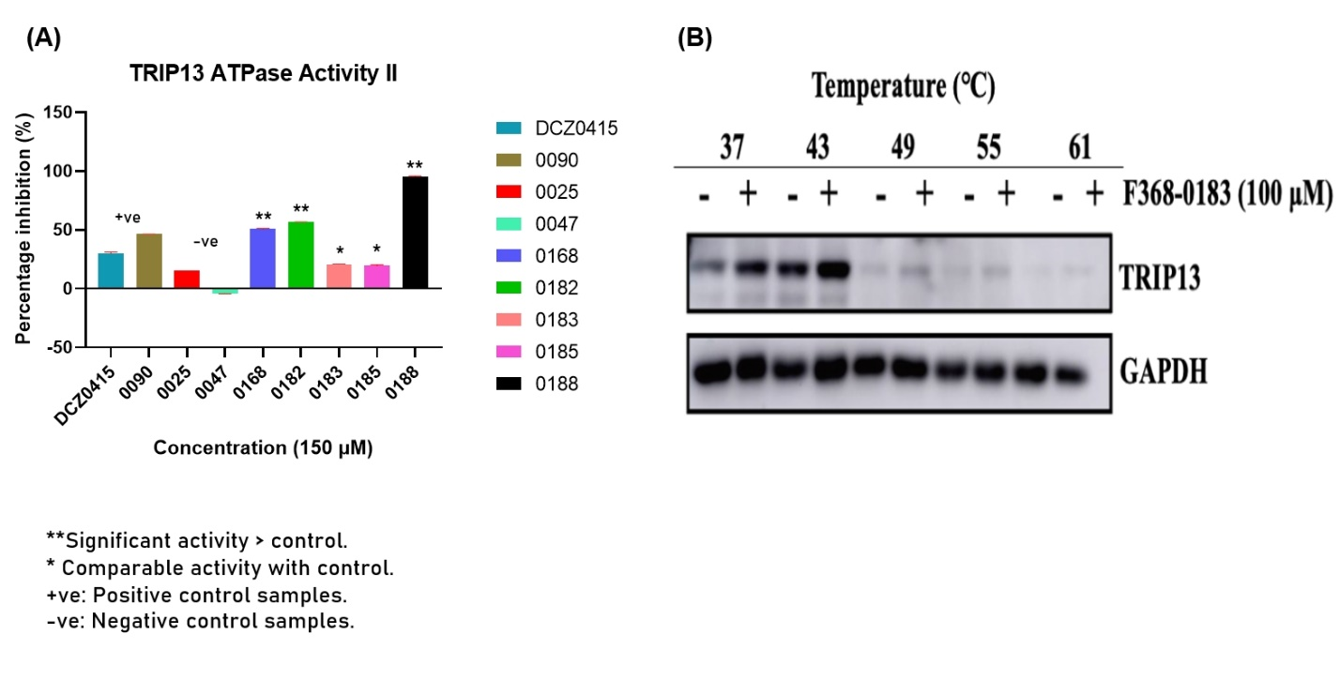

***Fig. 4 TRIP13 AAA+ ATPase inhibition and CETSA*A. :** Relative TRIP13 AAA+ ATPase inhibitory activity analysis of all active compounds, standard control, hit compound, and 2 compounds (F368-0025 and F368-0047) as negative control, were examined after treatment by ADP-GloTM Kinase. **B:** Cellular Thermal Shift Assay (CETSA) of F368-0183 in NCI-H929 cells. All results are expressed as mean ± SD of three independent experiments and *p≤0.01, **p≤0.001.

To justify the ATPase inhibitory properties of the active compounds, two similar compounds (F368-0025 and F368-047) that showed low antiproliferative activities were used as the negative control for the AAA+ ATPase bioassay (**Table S5†**). The analysis showed that these compounds possess lower ATPase inhibitory properties than all the five compounds, the positive control (DCZ0415) and hit compound (F368-0090) respectively. Low AAA+ ATPase inhibitory action was observed from the two-negative control compounds (**Fig. 4A**).

We then performed a normalization statistical analysis to compare the antiproliferative and TRIP13 ATPase bioassay with the computational molecular docking results (**Fig. S8†**). The normalization was based on the positive control (DCZ0415) results in correlation with our test results obtained from the respective analysis as indicated. Overall, F368-0182 and F368-0188 are the two best inhibitors.

To validate the binding characteristic of these compounds to target TRIP13 in MM cells, we conducted a Cellular Thermal Shift Assay (CETSA).74, 75 Compound F368-0183 was selected for the CETSA analysis because of its good solubility and good antiproliferative properties. Our result demonstrated that treatment with F368-0183 increased the thermal stability of TRIP13 protein at different temperatures compared with the control group in NCI-H929 cells (**Fig. 4B**). CETSA showed that the novel TRIP13 inhibitor (F368-0183) was able to stabilize the TRIP13 protein in MM cells. These results confirmed that compound F368-0183 interacts with TRIP13 in NCI-H929 cells.

* 1. ***Binding mechanism analysis of new hits***

The molecular docking studies showed that F368-0168, F368-0182, F368-0183, F368-0185, and F368-0188 could interact with diverse amino residues, as the control compound DCZ0415.13 All five molecules were observed to have high hydrophobic interactions with the TRIP13. Hydrogen bonding interactions were observed in F368-0168 between the amide group (C=O) with SER-187 and the aliphatic secondary amine group (N-H) with GLU-131 residues (**Fig. 5A**). A pi-cation interaction was revealed between the methylated benzene and ARG-386, polar interactions were observed with SER-187, THR-186, THR-193, SER-138, and HID-1333, and several hydrophobic interactions including VAL-140, LEU-139, TYR-141, etc., among other interactions (**Fig. S3†**). Thus, the amide C=O and N-H groups might be essential to the bioactivity of F368-0168.

For F368-0182, a hydrogen bonding interaction was observed at ARG-386 with the amide (C=O) group (**Fig. 5B**). A salt bridge was observed between the cyclic amine and ASP-252 residue, with some polar (SER-187, THR-186, GLN-153, THR-183, etc.) and hydrophobic (VAL-140, ILE-330, THR-141, PRO-322 etc.), interactions (**Fig. S4†**). Thus, the amide C=O and cyclic N-H might be useful for protein-ligand interactions and bioactivity. Our molecular docking and binding analysis revealed two hydrogen bonding interactions between the aliphatic N-H of F368-0183 with ASP-252 and the amide C=O with ARG-386, respectively (**Fig. 5C**), among other similar forms of interactions observed in other active compounds (**Fig. S5†**). Hence, the aliphatic N-H and amide C=O might be significant for F368-0183 bioactivity.

F368-0185 also formed (H-bonding interaction between the amide C=O with SER-187 (**Fig. 5D**). A pi-cation interaction was observed between the methylated benzene ring and ARG-386, coupled with other polar (THR-186, SER-138, etc.), and hydrophobic (VAL-140, TYR-141, etc.) interactions (**Fig. S6†**). Also, the docking results revealed a hydrogen bonding interaction between the C=O group of F368-0188 and SER-187 (**Fig. 5E**), and a pi-cation interaction between the benzene ring and ARG-386, as well as hydrophobic (VAL-140, LEU-139, TYR-141, etc.), and polar (THR-183, THR-186, SER-138, etc.) interactions (**Fig. S7†**). Hence, the amide C=O and benzene ring might be useful for both F368-0185 and F368-0188 protein-ligand interactions and bioactivity.

It is worth noting that DCZ0415 binds to the VAL-140, SER-187, and ARG-386 residues of the TRIP13 protein,13 and all novel TRIP13 inhibitors were observed to interact with these residues, indicating their potential to inhibit TRIP13 functions. This was also evident in the docking score obtained as all the novel compounds except F368-0168 (-7.31 kcal/mol) had better docking scores than DCZ0415 (-7.97 kcal/mol), ranging from F368-0183 (-8.11 kcal/mol), F368-0182 (-8.14 kcal/mol), F368-0188 (-8.19 kcal/mol), and F368-0185 (-8.28 kcal/mol) with PDB: 6LK0, respectively.

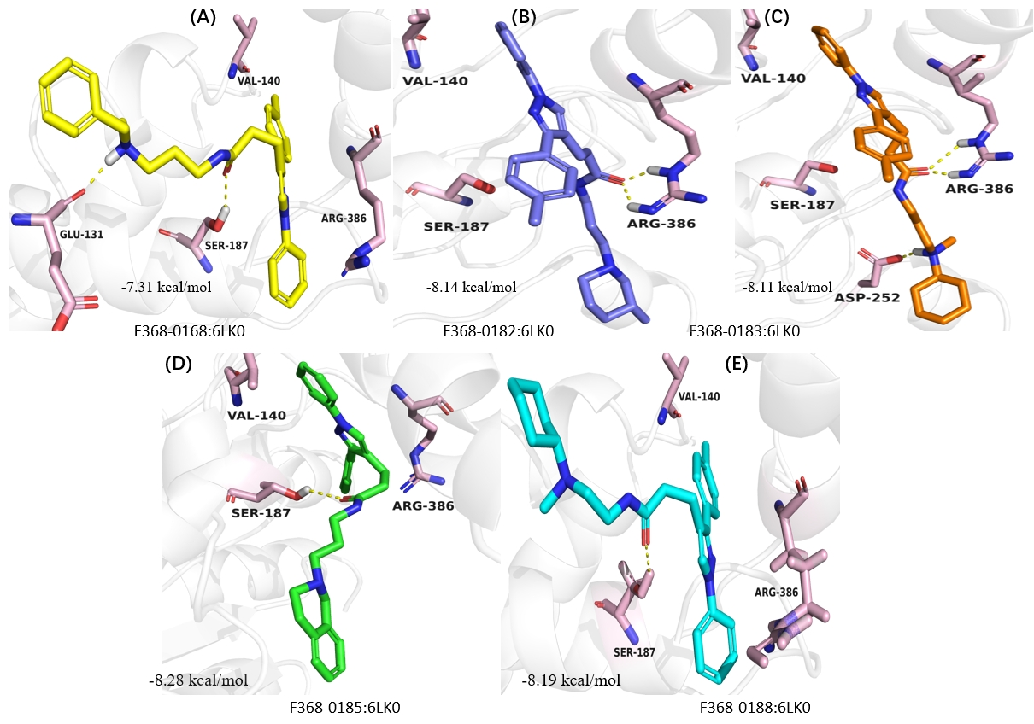

***Fig. 5 Molecular docking and binding analysis.* A:** The binding poses of F368-0168 on TRIP13 as determined by our molecular docking studies. **B-C:** F368-0182 and F368-0183 binding modes on TRIP13. **D-E:** The binding modes of F368-0185 and F368-0188 on TRIP13.

* 1. ***Molecular dynamic simulations***

Binding free energies (ΔG) of ligands to TRIP13 was accessed in the MD simulation. Based on 200 ns molecular dynamics simulations, ΔG calculations were performed for each system across three parallel simulations (**Table 1**). The predicted ΔG of TRIP13 with active ligands (F368-0182, F368-0183, F368-0168, F368-0185, and F368-0188) were -41.78 ± 1.33, -37.52 ± 2.28, -36.25 ± 2.22, -36.79 ± 2.94 and -37.72 ± 2.27 kcal/mol, while the ΔG values for the inactive compoundF368-0047 were -30.31 ± 1.25 kcal/mol, respectively, indicating a significant difference in binding affinities. ΔG decomposition analysis indicated that the key residues contributing to the binding of ligands to TRIP13 were similar but some residues contributed more in the system of active compounds with the TRIP13 protein (**Fig. S9†**).

**Table 1.** Predicted binding free energies (kcal/mol) of ligands to TRIP13 protein

|  |  |  |  |  |  |
| --- | --- | --- | --- | --- | --- |
| **Ligand**  **ID** | **P-value** | **ΔG**  **(Average)** | **ΔG**  **(Simulation 1)** | **ΔG**  **(Simulation 2)** | **ΔG**  **(Simulation 3)** |
| F368-0047 |  | -30.31 ± 1.25 | -28.86 ± 3.93 | -30.14 ± 4.38 | -31.92 ± 4.23 |
| F368-0182 | ** | -41.78 ± 1.33 | -39.93 ± 6.07 | -42.46 ± 4.89 | -42.96 ± 4.50 |
| F368-0183 | ** | -37.52 ± 2.28 | -39.96 ± 6.56 | -38.12 ± 6.34 | -34.48 ± 4.36 |
| F368-0168 | * | -36.25 ± 2.22 | -33.12 ± 4.63 | -37.66 ± 4.69 | -37.97 ± 5.16 |
| F368-0185 | * | -36.79 ± 2.94 | -33.31 ± 5.06 | -36.57 ± 7.42 | -40.50 ± 4.30 |
| F368-0188 | ** | -37.72 ± 2.27 | -40.78 ± 5.24 | -35.32 ± 5.17 | -37.07 ± 4.74 |

*NS, not significant; *P < 0.05, **P < 0.01*

From the binding free energy calculations, there was no statistically significant difference between F368-0183, F368-0168, F368-0185, and F368-0188 in ΔG values compared to F368-0182, indicating comparable binding affinities. The negative control compounds, F368-0025 and F368-0047 showed significant differences in ΔG values, indicating weaker binding affinity compared to F368-0182. To further examine binding stabilities, the RMSD of every system in each simulation was also calculated (**Fig. S10†**). The variance across the three MD simulations (1, 2, and 3) for each ligand suggests some level of consistency, although F368-0188 shows greater variation across runs, which might imply conformational flexibility or sensitivity to simulation parameters. Overall, there was a favorable binding affinity among the 5-active potential TRIP13 inhibitors with F368-0182 having the best ΔG, compared with the two negative controls, where F368-0025 showed the worst ΔG, respectively.

* 1. *Free energy perturbation calculation*

To further evaluate the activity of the five active compounds, FEP calculations were performed. The free energy differences for the five active compounds—F368-0168, F368-0182, F368-0183, F368-0185, and F368-0188—were calculated (**Table 2**).

Table 2. Relative Binding Free Energies of 5 active Compounds

|  |  |  |
| --- | --- | --- |
| Ligand Pair | Similarity Score | ΔΔG(raw)FEP |
| F368-0182→F368-0183 | 0.954 | 1.288±0.640 |
| F368-0183→F368-0168 | 0.837 | -0.271±0.343 |
| F368-0185→F368-0168 | 0.818 | -2.317±0.684 |
| F368-0185→F368-0183 | 0.768 | -1.200±0.581 |
| F368-0183→F368-0188 | 0.765 | -1.963±0.367 |
| F368-0188→F368-0182 | 0.754 | 2.176±0.224 |
| F368-0188→F368-0168 | 0.691 | 2.712±0.378 |
| F368-0185→F368-0188 | 0.646 | -1.305±0.519 |

The results indicate that F368-0188 exhibited the most favorable binding affinity among the five compounds. Except for F368-0188, F368-0182 and F368-0168 showed similar activities, and F368-0183 and F368-0185 were the worst among the five compounds (**Fig. 6**). These findings are consistent with the observed TRIP13 AAA+ ATPase inhibitory activity.

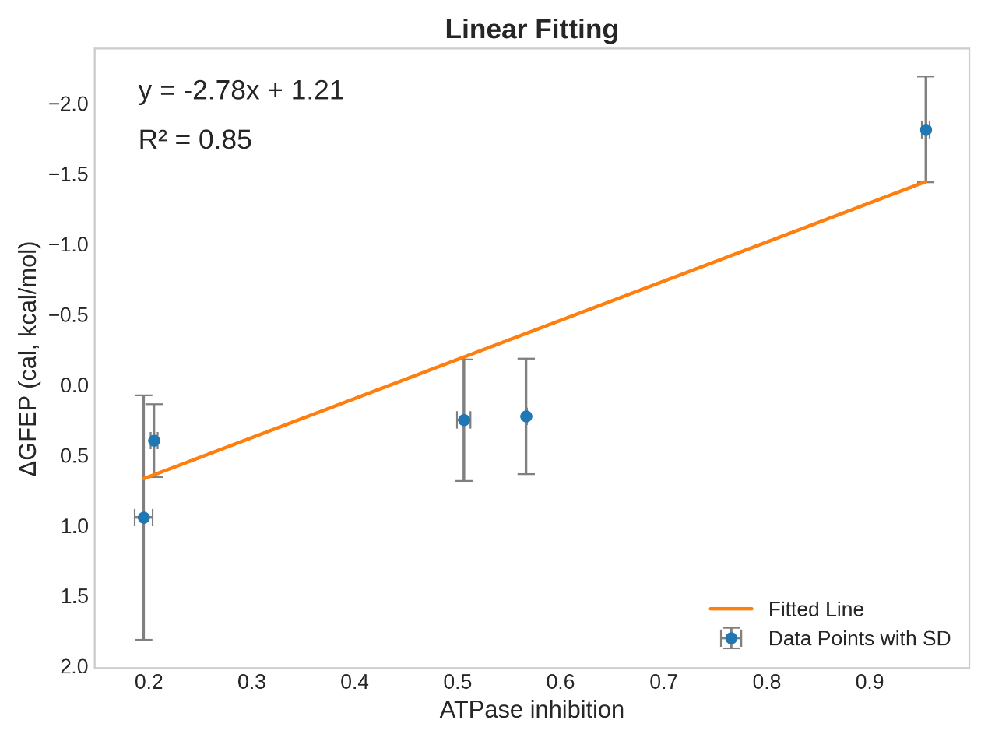

Fig. 6 The correlation plot of TRIP13 AAA+ ATPase inhibitory activity and Uni-FEP calculation results of novel TRIP13 inhibitors.

* 1. ***Preliminary structural-activity analysis***

Interestingly, 3-(1-phenyl-3-(p-tolyl)-1H-pyrazol-4-yl) propenamide was the basic pharmacophore found in these molecules with different substituents at **C4** of the pyrazole ring. Hence, they could be referred to as phenyl-pyrazole derivatives (**Fig. S11†**). The presence of different functional groups on substituents attached to the parent molecule of drug compounds is known to influence the overall pharmacological, and physicochemical properties, and drug-receptor interactions.76-79

F368-0168 consists of N-benzyl-N-methyl propylamine substituent. The propenamide chain links the substituent to the basic nucleus of the molecule. The other four compounds had substituents including 3-methyl-1-propyl piperidine (F368-0182), N-methyl-N-propylcyclohexanamine (F368-0183), 2-propyl-1,2,3,4-tetrahydroisoquinoline (F368-0185), and 1,4-dipropyl piperazine (F368-0188), respectively, all linked to the basic pharmacophore through propenamide side chain. Following the antiproliferative results, F368-0183 showed the highest IC50 which could be due to the presence of the N-methyl-cyclohexanamine group. F368-0182 and F368-0188 consist of 3-methyl-1-propyl piperidine and 1,4-dipropyl piperazine as substituents, with F368-0182 having better bioactivity. On the other hand, the antiproliferative activity of F368-0188 was less in both cell lines compared with F368-0183 but showed good AAA+ ATPase inhibitory activity. This depicts that the N-methyl-cyclohexanamine in F368-183 and propyl-piperazine of F368-0188 might offer better pharmacological advantages over the methyl-piperidine in F368-0182. Finally, the substituents of F368-0168 and F368-0185 both consist of a benzene ring, with F368-0185 having hydro-isoquinoline as a major substitute. The bioactivity of F368-0168 was better than that of F368-0185, indicating that the N-benzyl-N-methylamine of F368-0168 could offer better bioactivity than the hydro-isoquinoline of F368-0185.

1. **Conclusion**

This study discovered novel compounds that inhibit TRIP13-induced MM cells proliferation and enzymatic activities. We conducted a docking-based virtual screening and subsequent ligand-based similarity search of small organic molecules database to identify potential TRIP13 inhibitors that could be used as potential drug leads in the design of antimyeloma pharmacotherapy. Five compounds including F368-0168, F368-0182, F368-0183, F368-0185, and F368 were observed to possess good anti-proliferative inhibitory properties against H929 and ARP-1 MM cell lines. These compounds consist of 3-(1-phenyl-3-(p-tolyl)-1H-pyrazol-4-yl) propenamide as the basic scaffold with diverse substituents in their molecular structures including N-methyl-cyclohexanamine, methyl-piperidine, N-benzyl-N-methylamine, hydro-isoquinoline, and propyl-piperazine linked by a propyl bridge at the amide functional group. All five compounds formed pi-pi hydrogen interaction with the amide C=O, while some formed additional interactions with the aliphatic, cyclic N-H, or the benzene ring, indicating that the presence of these groups might be essential to the bioactivity.

Based on the 200 ns molecular dynamics simulations and binding free energy (ΔG) calculations, all compounds showed good interactions (ΔG) with the TRIP13 protein. Also, our CETSA result demonstrated that treatment with F368-0183 increased the thermal stability of TRIP13 protein at different temperatures compared with the control group, confirming that F368-0183 interacts with TRIP13 in NCI-H929 cells. From the above result, showing the ability of our compounds to suppress MM cell line proliferation and CETSA, as well as the displayed AAA+ ATPases inhibitory activity, these compounds could serve as TRIP13 inhibitors in the treatment of MM after careful optimization and well-designed preclinical and clinical studies.

**Data availability**

The original contributions presented in the study are included in the article or supplementary information (SI†). Further inquiries can be directed to the corresponding author.

**Authors Contribution**

**S. J. Bunu**: Writing – original draft, review & editing, Methodology, Formal analysis, Data curation, Project administration. **H. Cai**: Writing – review & editing, Methodology, Formal analysis, Data curation, Project administration. **Z. Zhou**: Formal analysis, Methodology. **Y. Zhang, Y. Lai, & G. Wang:** Formal analysis, Data curation. **Z. Xu**: Writing – review & editing, Supervision, Project administration, Funding acquisition. **J. Shi**: Supervision. **W. Zhu**: Conceptualization, Writing – review & editing, Supervision, Project administration, Funding acquisition.

**Conflicts of interest**

There are no conflicts to declare.

**Acknowledgments**

This work has been financed by the National Key Research and Development Program of China (2022YFA1004304), the National Natural Science Foundation of China (82273851, 82322067), and the Alliance International Science Organization (CAS-ANSO) Scholarship for Young Talents (2022ANP10025).

**Notes and references**

1. K. Wang, B. Sturt-Gillespie, J. C. Hittle, D. Macdonald, G. K. Chan, T. J. Yen and S. T. Liu, *J Biol Chem*, 2014, **289**, 23928-23937.

2. S. Miniowitz-Shemtov, E. Eytan, S. Kaisari, D. Sitry-Shevah and A. Hershko, *Proc Natl Acad Sci U S A*, 2015, **112**, 11536-11540.

3. J. Lan, J. Huang, X. Tao, Y. Gao, L. Zhang, W. Huang, J. Luo, C. Liu, Y. Deng, L. Liu and X. Liu, *J Cell Mol Med*, 2022, **26**, 2673-2685.

4. M. Rios Garcia, B. Meissburger, J. Chan, R. M. de Guia, F. Mattijssen, S. Roessler, A. L. Birkenfeld, N. Raschzok, F. Riols, J. Tokarz, M. Giroud, M. Gil Lozano, G. Hartleben, P. Nawroth, M. Haid, M. López, S. Herzig and M. Berriel Diaz, *Adv Sci (Weinh)*, 2022, **9**, e2104291.

5. F. Ni, X. Liu, Y. Xia, H. Zhu, F. Li, N. Zhang and H. Xu, *Funct Integr Genomics*, 2023, **23**, 232.

6. L. Wu, Q. Xue and X. Xia, *Mutat Res*, 2024, **828**, 111854.

7. R. Lu, Q. Zhou, L. Ju, L. Chen, F. Wang and J. Shao, *Oncol Rep*, 2021, **46**.

8. L. Zeng, Y. M. Liu, N. Yang, T. Zhang and H. Xie, *Front Mol Biosci*, 2021, **8**, 693477.

9. K. S. Zhou, Q. Zhang, W. T. Zhang, Y. Y. Liu, S. S. Wu, J. Zhou, X. D. Wei and Y. P. Song, *Zhonghua Xue Ye Xue Za Zhi*, 2017, **38**, 618-622.

10. K. Zhou, W. Zhang, Q. Zhang, R. Gui, H. Zhao, X. Chai, Y. Li, X. Wei and Y. Song, *Oncotarget*, 2017, **8**, 25469-25481.

11. W. Dazhi, Z. Mengxi, C. Fufeng and Y. Meixing, *Biomark Med*, 2017, **11**, 19-31.

12. S. Yost, B. de Wolf, S. Hanks, A. Zachariou, C. Marcozzi, M. Clarke, R. de Voer, B. Etemad, E. Uijttewaal, E. Ramsay, H. Wylie, A. Elliott, S. Picton, A. Smith, S. Smithson, S. Seal, E. Ruark, G. Houge, J. Pines, G. Kops and N. Rahman, *Nat Genet*, 2017, **49**, 1148-1151.

13. Y. Wang, J. Huang, B. Li, H. Xue, G. Tricot, L. Hu, Z. Xu, X. Sun, S. Chang, L. Gao, Y. Tao, H. Xu, Y. Xie, W. Xiao, D. Yu, Y. Kong, G. Chen, X. Sun, F. Lian, N. Zhang, X. Wu, Z. Mao, F. Zhan, W. Zhu and J. Shi, *Cancer Res*, 2020, **80**, 536-548.

14. S. Dong, K. Hu, Y. Shi, G. Wang, D. Yu, Y. Zhao, H. Zhang, Y. Wang, H. Sun, Z. Xu, Q. Jia, Y. Li, Y. Li, B. Li, J. Shi and W. Zhu, *Bioorg Med Chem Lett*, 2024, **98**, 129590.

15. G. M. H. Abdel-Salam, S. Hellmuth, E. Gradhand, S. Käseberg, J. Winter, A. S. Pabst, M. M. Eid, H. Thiele, P. Nürnberg, B. S. Budde, M. R. Toliat, I. B. Brecht, C. Schroeder, A. Gschwind, S. Ossowski, F. Häuser, H. Rossmann, M. S. Abdel-Hamid, I. Hegazy, A. G. Mohamed, D. T. Schneider, A. Bertoli-Avella, P. Bauer, J. N. Pearring, R. Pfundt, A. Hoischen, C. Gilissen, D. Strand, U. Zechner, S. A. Tashkandi, E. A. Faqeih, O. Stemmann, S. Strand and H. J. Bolz, *JCI Insight*, 2023, **8**.

16. J. Guo, W. B. He, L. Dai, F. Tian, Z. Luo, F. Shen, M. Tu, Y. Zheng, L. Zhao, C. Tan, Y. Guo, L. L. Meng, W. Liu, M. Deng, X. Wu, Y. Peng, S. Zhang, G. X. Lu, G. Lin, H. Wang, Y. Q. Tan and Y. Yang, *HGG Adv*, 2024, **5**, 100256.

17. C. Li, J. Xia, R. Franqui-Machin, F. Chen, Y. He, T. C. Ashby, F. Teng, H. Xu, D. Liu, D. Gai, S. K. Johnson, F. van Rhee, S. Janz, J. D. Shaughnessy, Jr., G. Tricot, I. Frech and F. Zhan, *J Clin Invest*, 2021, **131**.

18. S. Lu, J. Qian, M. Guo, C. Gu and Y. Yang, *Comput Struct Biotechnol J*, 2019, **17**, 854-861.

19. J. Xue, H. Wu, Y. Shi and Z. Li, *Discov Oncol*, 2023, **14**, 176.

20. C. S. Clairmont, P. Sarangi, K. Ponnienselvan, L. D. Galli, I. Csete, L. Moreau, G. Adelmant, D. Chowdhury, J. A. Marto and A. D. D'Andrea, *Nat Cell Biol*, 2020, **22**, 87-96.

21. I. de Krijger, B. Föhr, S. H. Pérez, E. Vincendeau, J. Serrat, A. M. Thouin, V. Susvirkar, C. Lescale, I. Paniagua, L. Hoekman, S. Kaur, M. Altelaar, L. Deriano, A. C. Faesen and J. J. L. Jacobs, *Nat Commun*, 2021, **12**, 5421.

22. K. D. Corbett, *Proc Natl Acad Sci U S A*, 2020, **117**, 27761-27763.

23. Q. Ye, D. H. Kim, I. Dereli, S. C. Rosenberg, G. Hagemann, F. Herzog, A. Tóth, D. W. Cleveland and K. D. Corbett, *Embo j*, 2017, **36**, 2419-2434.

24. H. T. Ma and R. Y. C. Poon, *Cell Rep*, 2016, **14**, 1086-1099.

25. H. T. Ma and R. Y. C. Poon, *Cell Rep*, 2018, **22**, 1439-1450.

26. M. L. Brulotte, B. C. Jeong, F. Li, B. Li, E. B. Yu, Q. Wu, C. A. Brautigam, H. Yu and X. Luo, *Nat Commun*, 2017, **8**, 1956.

27. L. Défachelles, A. E. Russo, C. R. Nelson and N. Bhalla, *Mol Biol Cell*, 2020, **31**, 2219-2233.

28. S. Lu, M. Guo, Z. Fan, Y. Chen, X. Shi, C. Gu and Y. Yang, *Am J Transl Res*, 2019, **11**, 4397-4410.

29. Z. Xiao, M. Li, X. Zhang, X. Rong and H. Xu, *Oncol Rep*, 2023, **49**.

30. R. Banerjee, M. Liu, E. Bellile, L. B. Schmitd, M. Goto, M. N. D. Hutchinson, P. Singh, S. Zhang, D. P. V. Damodaran, M. K. Nyati, M. E. Spector, B. Ward, G. Wolf, K. Casper, M. Mierzwa and N. J. D'Silva, *Mol Ther*, 2022, **30**, 468-484.

31. R. Banerjee, N. Russo, M. Liu, V. Basrur, E. Bellile, N. Palanisamy, C. S. Scanlon, E. van Tubergen, R. C. Inglehart, T. Metwally, R. S. Mani, A. Yocum, M. K. Nyati, R. M. Castilho, S. Varambally, A. M. Chinnaiyan and N. J. D'Silva, *Nat Commun*, 2014, **5**, 4527.

32. G. Liu, H. Wang, R. Rui, Y. Wang and Y. Li, *Curr Med Chem*, 2024, DOI: 10.2174/0109298673255498231117100421.

33. L. Hu, J. Shi, D. Shen, X. Zhai, D. Liang, J. Wang, C. Xie, Z. Xia, J. Cui, F. Liu, S. Du, S. Meng and H. Piao, *Cell Death Discov*, 2023, **9**, 333.

34. L. T. Zhang, L. X. Ke, X. Y. Wu, H. T. Tian, H. Z. Deng, L. Y. Xu, E. M. Li and L. Long, *Biomed Res Int*, 2022, **2022**, 7295458.

35. S. Di, M. Li, Z. Ma, K. Guo, X. Li and X. Yan, *Pathol Res Pract*, 2019, **215**, 152415.

36. S. Ge, R. Gu, X. Yang, C. Xu, S. Wang and G. Zhu, *Zhongguo Fei Ai Za Zhi*, 2024, **27**, 1-12.

37. Y. Tao, G. Yang, H. Yang, D. Song, L. Hu, B. Xie, H. Wang, L. Gao, M. Gao, H. Xu, Z. Xu, X. Wu, Y. Zhang, W. Zhu, F. Zhan and J. Shi, *Oncotarget*, 2017, **8**, 26718-26731.

38. A. Kowalewski, D. Jaworski, P. Antosik, M. Smolińska, J. Ligmanowska, D. Grzanka and Ł. Szylberg, *Am J Cancer Res*, 2020, **10**, 2909-2918.

39. Y. Chen, D. Chen, Y. Qin, C. Qiu, Y. Zhou, M. Dai, L. Li, Q. Sun and Y. Jiang, *Cell Death Discov*, 2022, **8**, 35.

40. S. Jacob Bunu, H. Cai, L. Wu, H. Zhang, Z. Zhou, Z. Xu, J. Shi and W. Zhu, *Bioorganic Chemistry*, 2024, **151**, 107650.

41. L. Zhao, S. Ye, S. Jing, Y. J. Gao and T. He, *Oncol Rep*, 2023, **50**.

42. D. H. Marks, R. Thomas, Y. Chin, R. Shah, C. Khoo and R. Benezra, *Cell Rep*, 2017, **19**, 1832-1845.

43. L. Xu, Y. Wang, G. Wang, S. Guo, D. Yu, Q. Feng, K. Hu, G. Chen, B. Li, Z. Xu, X. Jia, Y. Lu, H. Zhang, X. Gao, S. Chang, H. Wang, X. Wu, D. Song, G. Yang, H. Zhu, J. Zhou, F. Zhan, W. Zhu and J. Shi, *Leukemia*, 2023, **37**, 1576-1579.

44. S. K. Kumar, N. S. Callander, K. Adekola, L. Anderson, M. Baljevic, E. Campagnaro, J. J. Castillo, J. C. Chandler, C. Costello, Y. Efebera, M. Faiman, A. Garfall, K. Godby, J. Hillengass, L. Holmberg, M. Htut, C. A. Huff, Y. Kang, M. Hultcrantz, S. Larson, M. Liedtke, T. Martin, J. Omel, K. Shain, D. Sborov, K. Stockerl-Goldstein, D. Weber, J. Keller and R. Kumar, *J Natl Compr Canc Netw*, 2020, **18**, 1685-1717.

45. Z. S. Bernstein, E. B. Kim and N. Raje, *Cells*, 2022, **11**.

46. A. Schavgoulidze, T. Cazaubiel, A. Perrot, H. Avet-Loiseau and J. Corre, *Cancers (Basel)*, 2021, **13**.

47. G. Chen, X. Gao, X. Jia, Y. Wang, L. Xu, D. Yu, S. Chang, H. Deng, K. Hu, G. Wang, B. Li, Z. Xu, Y. Lu, H. Wang, T. Zhang, D. Song, G. Yang, X. Wu, H. Zhu, W. Zhu and J. Shi, *Haematologica*, 2024, **109**, 1206-1219.

48. F. Esma, M. Salvini, R. Troia, M. Boccadoro, A. Larocca and C. Pautasso, *Expert Opin Pharmacother*, 2017, **18**, 1127-1136.

49. J. F. San-Miguel, V. T. Hungria, S. S. Yoon, M. Beksac, M. A. Dimopoulos, A. Elghandour, W. W. Jedrzejczak, A. Günther, T. N. Nakorn, N. Siritanaratkul, P. Corradini, S. Chuncharunee, J. J. Lee, R. L. Schlossman, T. Shelekhova, K. Yong, D. Tan, T. Numbenjapon, J. D. Cavenagh, J. Hou, R. LeBlanc, H. Nahi, L. Qiu, H. Salwender, S. Pulini, P. Moreau, K. Warzocha, D. White, J. Bladé, W. Chen, J. de la Rubia, P. Gimsing, S. Lonial, J. L. Kaufman, E. M. Ocio, L. Veskovski, S. K. Sohn, M. C. Wang, J. H. Lee, H. Einsele, M. Sopala, C. Corrado, B. R. Bengoudifa, F. Binlich and P. G. Richardson, *Lancet Oncol*, 2014, **15**, 1195-1206.

50. S. Chang, W. Xiao, Y. Xie, Z. Xu, B. Li, G. Wang, K. Hu, Y. Zhang, J. Zhou, D. Song, H. Zhu, X. Wu, Y. Lu, J. Shi and W. Zhu, *Cancer Med*, 2023, DOI: 10.1002/cam4.6706.

51. Y. Wang, S. Dong, K. Hu, L. Xu, Q. Feng, B. Li, G. Wang, G. Chen, B. Zhang, X. Jia, Z. Xu, X. Gao, H. Zhang, Y. Xie, M. Lu, S. Chang, D. Song, X. Wu, Q. Jia, H. Zhu, J. Zhou, W. Zhu and J. Shi, *J Transl Med*, 2023, **21**, 858.

52. Z. M. Qian, Y. J. Chen and Y. X. Bao, *Am J Cancer Res*, 2023, **13**, 5024-5038.

53. T. Yang, R. Yu, C. Cheng, J. Huo, Z. Gong, H. Cao, Y. Hu, B. Dai and Y. Zhang, *J Transl Med*, 2023, **21**, 597.

54. X. Li, H. Zhang, S. Dong, X. Gao, H. Sun, Z. Zhou, K. Hu, S. Guo, Q. Zhang, Z. Guo, S. Jacob Bunu, J. Zhu, B. Li, Y. Zhang, J. Shen, H. Akber Aisa, Z. Xu, H. Cai, J. Shi and W. Zhu, *Bioorganic & Medicinal Chemistry*, 2024, DOI: <https://doi.org/10.1016/j.bmc.2024.117843>, 117843.

55. X. Liu, X. Shen and J. Zhang, *Environ Toxicol*, 2021, **36**, 1829-1840.

56. K. Mittal, G. W. Cooper, B. P. Lee, Y. Su, K. T. Skinner, J. Shim, H. C. Jonus, W. J. Kim, M. Doshi, D. Almanza, B. D. Kynnap, A. L. Christie, X. Yang, G. S. Cowley, B. A. Leeper, C. L. Morton, B. Dwivedi, T. Lawrence, M. Rupji, P. Keskula, S. Meyer, C. M. Clinton, M. Bhasin, B. D. Crompton, Y. Y. Tseng, J. S. Boehm, K. L. Ligon, D. E. Root, A. J. Murphy, D. M. Weinstock, P. C. Gokhale, J. M. Spangle, M. N. Rivera, E. A. Mullen, K. Stegmaier, K. C. Goldsmith, W. C. Hahn and A. L. Hong, *Commun Biol*, 2024, **7**, 426.

57. A. Kosterina, *Journal*, 2023.

58. Maestro, *Journal*, 2020.

59. G. M. Morris, R. Huey, W. Lindstrom, M. F. Sanner, R. K. Belew, D. S. Goodsell and A. J. Olson, *J Comput Chem*, 2009, **30**, 2785-2791.

60. J. Eberhardt, D. Santos-Martins, A. F. Tillack and S. Forli, *J Chem Inf Model*, 2021, **61**, 3891-3898.

61. I. J. Dos Santos Nascimento and R. O. de Moura, *Mini Rev Med Chem*, 2024, **24**, 1061-1062.

62. D. Milardi and M. Pappalardo, *Eur J Med Chem*, 2015, **91**, 1-3.

63. M. De Vivo, M. Masetti, G. Bottegoni and A. Cavalli, *J Med Chem*, 2016, **59**, 4035-4061.

64. D. Van Der Spoel, E. Lindahl, B. Hess, G. Groenhof, A. E. Mark and H. J. Berendsen, *J Comput Chem*, 2005, **26**, 1701-1718.

65. H. J. Berendsen, D. van der Spoel and R. J. C. p. c. van Drunen, 1995, **91**, 43-56.

66. L. Wang, R. A. Friesner and B. J. T. J. o. P. C. B. Berne, 2011, **115**, 9431-9438.

67. Y. Wang, J. Huang, B. Li, H. Xue, G. Tricot, L. Hu, Z. Xu, X. Sun, S. Chang, L. Gao, Y. Tao, H. Xu, Y. Xie, W. Xiao, D. Yu, Y. Kong, G. Chen, X. Sun, F. Lian, N. Zhang, X. Wu, Z. Mao, F. Zhan, W. Zhu and J. Shi, *Cancer Research*, 2020, **80**, 536-548.

68. C. S. Zhu, J. Li and H. Wang, *Bio Protoc*, 2023, **13**, e4795.

69. J. Baardsnes and B. Paul-Roc, *Methods Mol Biol*, 2024, **2762**, 71-87.

70. M. K. Grasmeier, S. Weber, M. Treiber, M. A. Thaler and P. B. Luppa, *Clin Chem Lab Med*, 2023, **61**, 1255-1265.

71. Y. Xie, Y. Wang, Z. Xu, Y. Lu, D. Song, L. Gao, D. Yu, B. Li, G. Chen, H. Zhang, Q. Feng, Y. Zhang, K. Hu, C. Huang, Y. Peng, X. Wu, Z. Mao, J. Shao, W. Zhu and J. Shi, *J Biomed Sci*, 2022, **29**, 32.

72. C. Alfieri, L. Chang and D. Barford, *Nature*, 2018, **559**, 274-278.

73. G. Vader, *Chromosoma*, 2015, **124**, 333-339.

74. H. Axelsson, H. Almqvist, B. Seashore-Ludlow and T. Lundbäck, in *Assay Guidance Manual*, eds. S. Markossian, A. Grossman, M. Arkin, D. Auld, C. Austin, J. Baell, K. Brimacombe, T. D. Y. Chung, N. P. Coussens, J. L. Dahlin, V. Devanarayan, T. L. Foley, M. Glicksman, K. Gorshkov, J. V. Haas, M. D. Hall, S. Hoare, J. Inglese, P. W. Iversen, M. Lal-Nag, Z. Li, J. R. Manro, J. McGee, O. McManus, M. Pearson, T. Riss, P. Saradjian, G. S. Sittampalam, M. Tarselli, O. J. Trask, Jr., J. R. Weidner, M. J. Wildey, K. Wilson, M. Xia and X. Xu, Eli Lilly & Company and the National Center for Advancing Translational Sciences, Bethesda (MD), 2004.

75. R. Jafari, H. Almqvist, H. Axelsson, M. Ignatushchenko, T. Lundbäck, P. Nordlund and D. Martinez Molina, *Nat Protoc*, 2014, **9**, 2100-2122.

76. L. Schaeffer, in *The Practice of Medicinal Chemistry (Fourth Edition)*, eds. C. G. Wermuth, D. Aldous, P. Raboisson and D. Rognan, Academic Press, San Diego, 2008, DOI: <https://doi.org/10.1016/B978-0-12-417205-0.00014-6>, pp. 359-378.

77. P. R. Andrews, D. J. Craik and J. L. Martin, *J Med Chem*, 1984, **27**, 1648-1657.

78. F. Mao, W. Ni, X. Xu, H. Wang, J. Wang, M. Ji and J. Li, *Molecules*, 2016, **21**, 75.

79. P. Ertl, E. Altmann and J. M. McKenna, *J Med Chem*, 2020, **63**, 8408-8418.