**2. Methods**

**2.9. SARS-CoV-2 PLpro inhibition assay**

Compound inhibitory activity against SARS-CoV-2 PLpro was determined using a fluorescence resonance energy transfer (FRET) protease assay. For IC50 measurements, SARS-CoV-2 PLpro was pre-incubated with each compound in assay buffer for 10 min at room temperature in a 384-well black polystyrene plate. The reaction was initiated by adding the substrate Z-RLRGG-AMC to a final concentration of 25 μM. Fluorescence (excitation/emission at 340 nm/490 nm) was monitored continuously using an EnVision multimode plate reader (Perkin Elmer). The initial reaction rate was determined from the linear phase of the kinetic curve. Dose-response curves were fitted using GraphPad Prism 8.0.

**3. Results and Discussion**

**3.7. Enzymatic inhibition assay**

To validate the inhibitory effects of the HSBD-derived compounds against SARS‑CoV‑2 Mpro and PLpro, we employed fluorescence resonance energy transfer (FRET) protease assays. Nine potential bioactive compounds identified from virtual screening (TCMID‑05973, TCMID‑15972, TCMID‑22246, TCMID‑22314, TCMID‑26509, TCMID‑27300, TCMID‑27476, TCMID‑27543, and TCMID‑28905) were preliminary screened at 10 μM and 100 μM. At 100 μM, isobavachalcone (TCMID‑27300) inhibited Mpro and PLpro by 93.8% and 43.6%, respectively. Glabrol (TCMID‑27476) inhibited Mpro by 93.4% and licoflavone B (TCMID‑15972) inhibited PLpro by 43.3%. These results revealed isobavachalcone, glabrol, and licoflavone B as the most promising antiviral compounds for further evaluation.

Subsequently, we determined their half‑maximal inhibitory concentrations (IC50) using nirmatrelvir and GRL0617 as positive controls for Mpro and PLpro, respectively. As depicted in Figure 5C and Figure 5D, isobavachalcone exhibited IC50 values of 6.27 μM against Mpro and 99.93 μM against PLpro. Glabrol showed an IC50 of 3.38 μM against Mpro (Figure 5C) and licoflavone B demonstrated an IC50 of 84.35 μM against PLpro (Figure 5D). The IC50 values of the controls were consistent with previously reported data, confirming assay reliability. While these three natural products exhibit promising inhibitory activity, they are less potent than nirmatrelvir and GRL0617. Nonetheless, their unique scaffolds compared with known Mpro and PLpro inhibitors present valuable starting points for structural optimization. Further medicinal chemistry efforts may enhance their potency, supporting the development of new antiviral agents based on natural products.

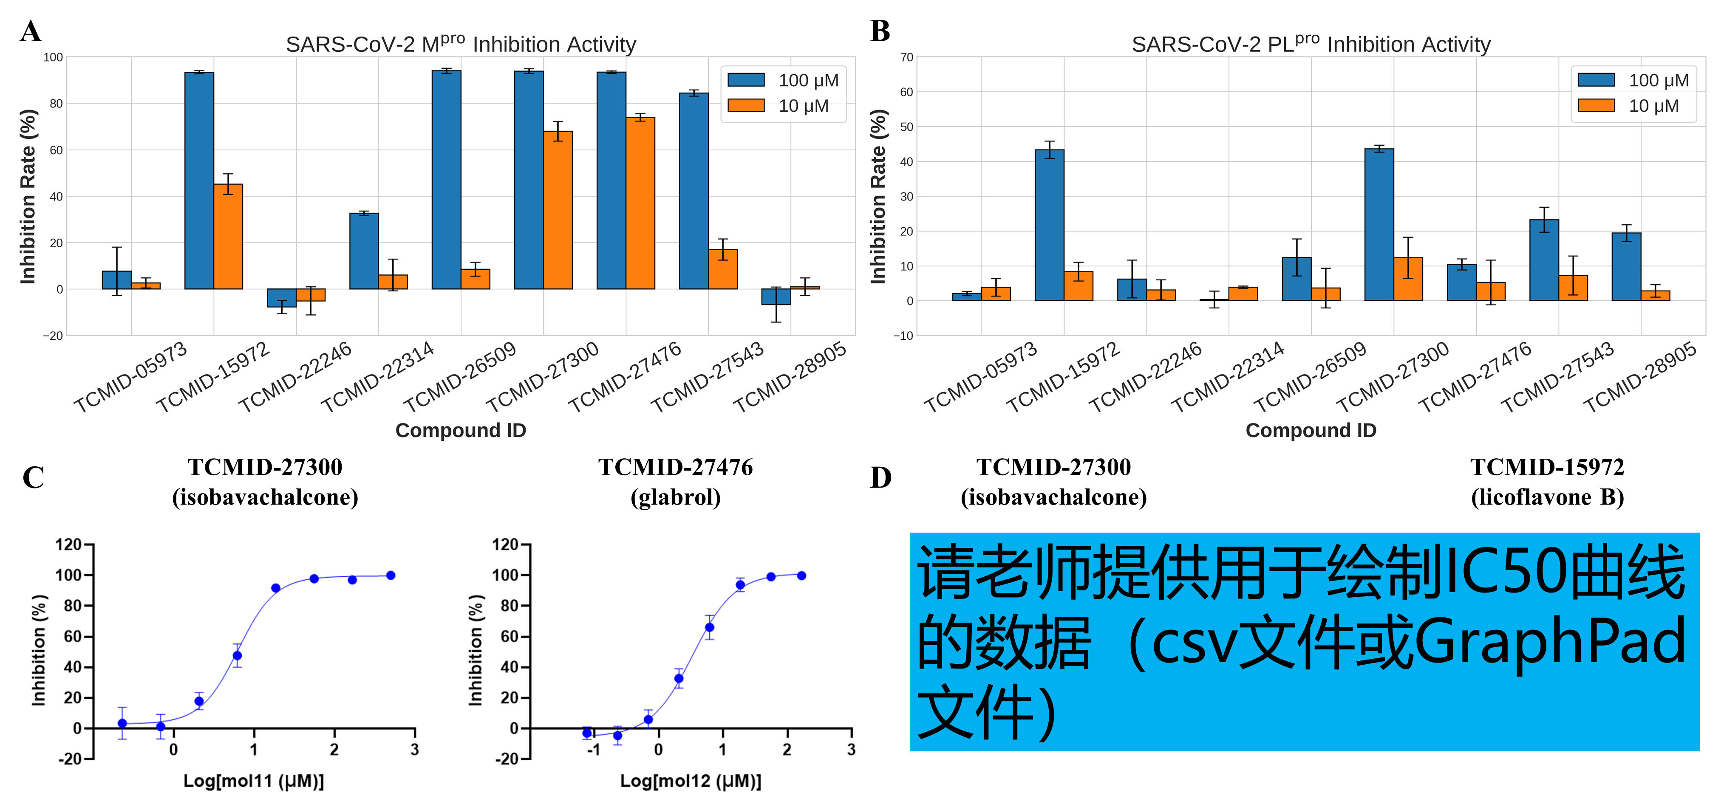

Fig. 5. The enzymatic inhibition assay results of nine potential bioactive compounds derived from HSBD. (A) SARS-CoV-2 Mpro inhibition %. (B) SARS-CoV-2 PLpro inhibition %. (C) Inhibitory activities (IC50) of representative compounds against SARS-CoV-2 Mpro. (D) Inhibitory activities (IC50) of representative compounds against SARS-CoV-2 PLpro.