Supporting Information

Bioactive Components and Mechanism of Wuwei Xiaodu Decoction in Mitigating LPS-Induced Inflammation in RAW264.7 Macrophages

Binghui Li ^{a, b 1}, Zhaoyin Zhou ^{b, c 1}, Yong Zhang ^{b 1}, Jing Zhu ^{b, d}, Qiyuan Liu ^{b, e}, Zhijian Xu^{b, e}, Jingshan Shen ^{b, e *}, Weiliang Zhu ^{b, e *}, Jia Chen^{f, g *}
a School of Pharmacy, Henan University, Kaifeng 475004, China;
b State Key Laboratory of Drug Research; Drug Discovery and Design Center, Shanghai Institute of Materia Medica, Chinese Academy of Sciences, Shanghai 201203, China;
c School of Chinese Materia Medica, Nanjing University of Chinese Medicine, 210023, Nanjing, China
d Institute of Chinese Materia Medica, Shanghai University of Traditional Chinese Medicine, Shanghai, 201203, China.
e School of Pharmacy, University of Chinese Academy of Sciences, Beijing 100049, China.
f Department of Integrative Medicine on Pediatrics, Shanghai Children’s Medical Center, Shanghai Jiao Tong University School of Medicine, Shanghai 200120, China
g Guizhou Branch of Shanghai Children’s Medical Center, Guizhou Provincial People’s Hospital, Guiyang 550009, China

Contents | Page
Fig S1. The analysis report of LC/MS | S2
Table S1. The analysis report of GC/MS | S4
Table S2. 85 target proteins with the highest predicted scores (above 0.99) among 123 compounds from WXD-PE | S12
Table S3. 57 target proteins with predicted scores exceeding 0.95 among the five most abundant compounds in WXD-PE
Table S4. 18 target proteins with predicted scores exceeding 0.95 for the most abundant compound (2,4-di-tert-butylphenol) in WXD-PE
Table S5. Target prediction results of the D3CARP platform for WXD-EA based on molecular docking | S15
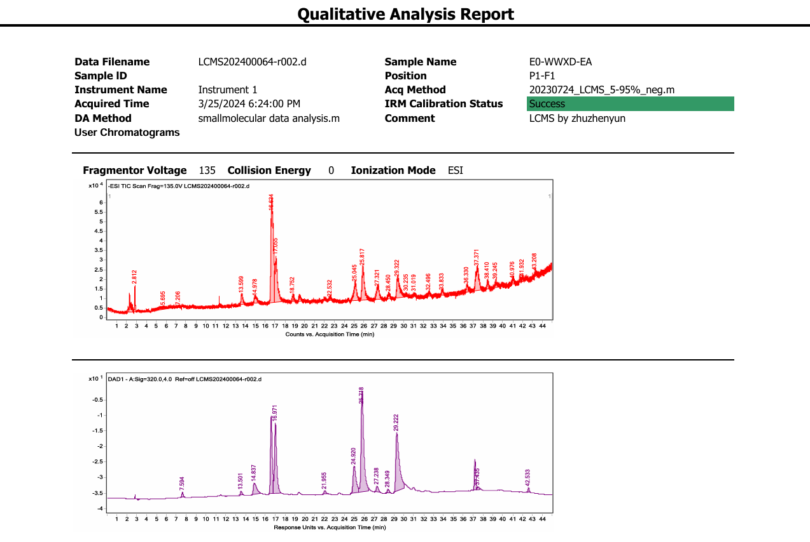
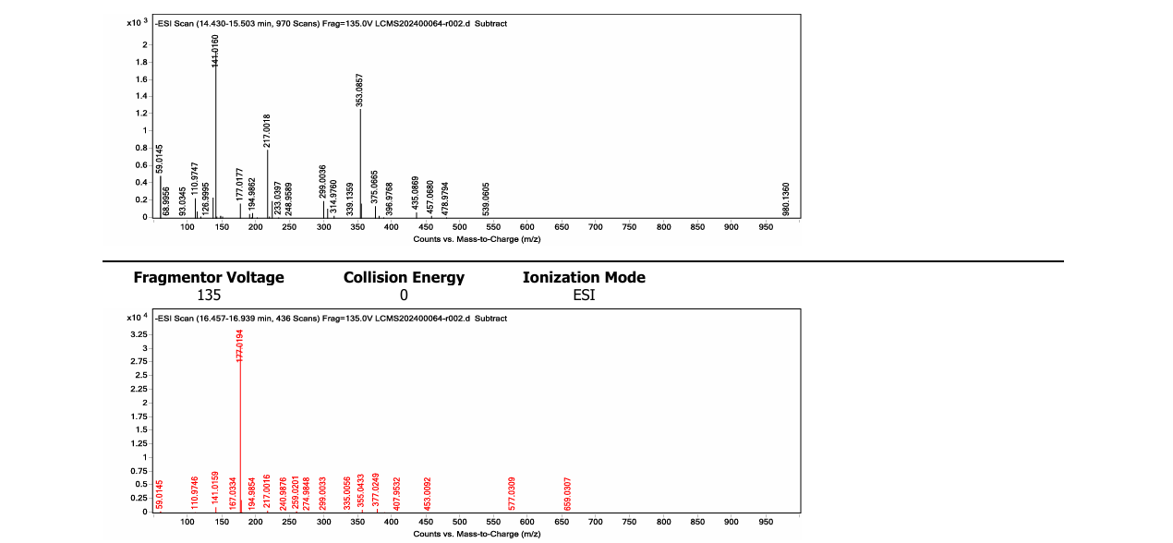

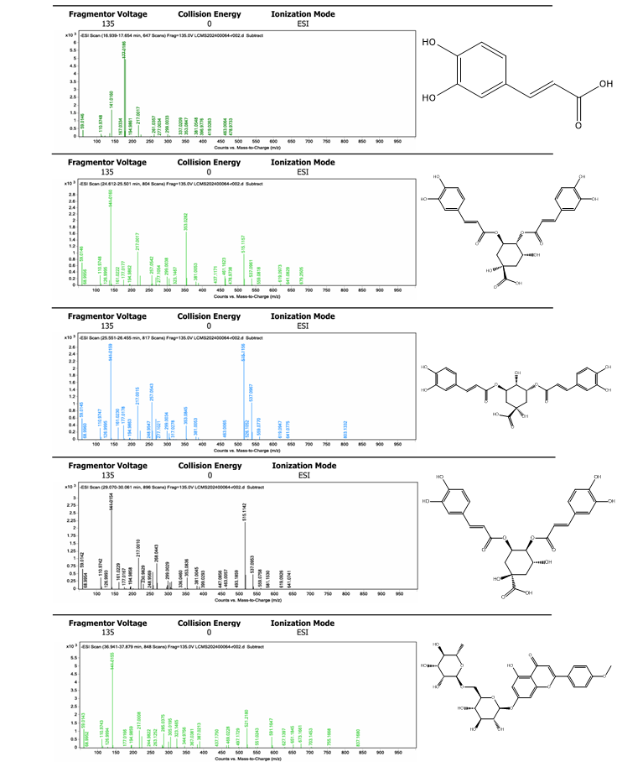
Fig S1. The analysis report of LC/MS. Comparing the LC-MS results with the molecular weights of compounds in the literature, 7 compounds were confirmed

Table S1. The analysis report of GC/MS

 | Component Name | Retention Time | Reference m/z | TIC | Formula (mol ion) | CAS No. | HRF Score
1 | 2,4-Di-tert-butylphenol | 13.347 | 191.143 | 1.12E+10 | C₁₄H₂₂O | 96-76-4 | 98.3847
2 | Mandelic acid, 3,4-dimethoxy-, methyl ester | 14.708 | 167.0703 | 3.83E+09 | C₁₁H₁₄O₅ | 2911-73-1 | 96.7867
3 | 1-Hexadecanol | 14.375 | 69.06995 | 2.34E+09 | C₁₆H₃₄O | 36653-82-4 | 99.8649
4 | 2(4H)-Benzofuranone, 5,6,7,7a-tetrahydro-4,4,7a-trimethyl-, (R)- | 13.675 | 111.0442 | 2.08E+09 | C₁₁H₁₆O₂ | 17092-92-1 | 98.9506
5 | 1-Eicosanol | 16.571 | 69.06995 | 2E+09 | C₂₀H₄₂O | 629-96-9 | 98.8406
6 | Undecane, 2,3-dimethyl- | 12.031 | 43.05426 | 1.97E+09 | C₁₃H₂₈ | 17312-77-5 | 99.6555
7 | 2-Butenoic acid, 2-methyl-, dodecahydro-8-hydroxy-8a-methyl-3,5-bis(methylene)-2-oxonaphtho[2,3-b]furan-4-yl ester, [3ar-[3a.alpha.,4.alpha.(Z),4a.alpha.,8.beta.,8a.beta.,9a.beta.]]- | 23.779 | 55.05436 | 1.74E+09 | C₂₀H₂₆O₅ | 34226-89-6 | 96.2045
8 | Nonadecane | 14.465 | 43.05426 | 1.52E+09 | C₁₉H₄₀ | 629-92-5 | 99.811
9 | n-Hexadecanoic acid | 18.242 | 87.0441 | 1.38E+09 | C₁₆H₃₂O₂ | 1957-10-3 | 99.516
10 | 9-Octadecene, (E)- | 11.923 | 69.06995 | 1.28E+09 | C₁₈H₃₆ | 7206-25-9 | 99.7997
11 | Reynosin | 19.841 | 81.06996 | 1.24E+09 | C₁₅H₂₀O₃ | 28254-53-7 | 98.6747
12 | 1-Tetracosene | 18.565 | 69.06995 | 1.17E+09 | C₂₄H₄₈ | 10192-32-2 | 99.3103
13 | 1H-Indene-1-methanol, .alpha.-methyl-, acetate | 10.688 | 141.0701 | 1.13E+09 | C₁₃H₁₄O₂ | 63839-85-0 | 93.2261
14 | 9,12,15-Octadecatrienoic acid, (Z,Z,Z)- | 19.881 | 93.06989 | 1.12E+09 | C₁₈H₃₀O₂ | 463-40-1 | 98.0374
15 | Tridecane | 10.706 | 43.05426 | 1.01E+09 | C₁₃H₂₈ | 629-50-5 | 98.2173
16 | Spirafolide | 18.363 | 123.0806 | 9.65E+08 | C₁₅H₁₈O₃ | 130838-06-1 | 96.9776
17 | Matricarin | 20.465 | 244.1094 | 7.34E+08 | C₁₇H₂₀O₅ | 5989-43-5 | 99.6799
18 | 3,5-di-tert-Butyl-4-hydroxyphenylpropionic acid | 18.44 | 263.1642 | 6.14E+08 | C₁₇H₂₆O₃ | 20170-32-5 | 97.2397
19 | Estafiatin | 19.149 | 231.1016 | 5.91E+08 | C₁₅H₁₈O₃ | 10180-89-9 | 96.3565
20 | (E)-2-(Hepta-2,4-diyn-1-ylidene)-1,6-dioxaspiro[4.4]non-3-ene | 17.86 | 115.0544 | 5.63E+08 | C₁₄H₁₄O₂ | 206062-17-1 | 96.4511
21 | Dibutyl phthalate | 18.175 | 149.0233 | 5.57E+08 | C₁₆H₂₂O₄ | 84-74-2 | 98.7463
22 | 2aS,3aR,5aS,9bR)-2a,5a,9-Trimethyl-2a,4,5,5a,6,7,8,9b-octahydro-2H-naphtho[1,2-b]oxireno[2,3-c]furan | 19.05 | 201.1274 | 5.45E+08 | C₁₅H₂₂O₂ | 352457-43-3 | 96.9057
23 | Cyclopropanecarboxylic acid, 2,2-dimethyl-3-(2-methyl-1-propenyl)-, (1R-trans)- | 11.187 | 109.1014 | 5.37E+08 | C₁₀H₁₆O₂ | 4638-92-0 | 98.0996
24 | 5-Isopropyl-2-methylphenethyl acetate | 11.007 | 105.0701 | 5.35E+08 | C₁₄H₂₀O₂ | 27913-43-5 | 98.5837
25 | Benzene, 1,3-bis(1-methylethyl)- | 10.015 | 131.0857 | 5.29E+08 | C₁₂H₁₈ | 99-62-7 | 98.2743
26 | Benzenepropanoic acid, 3,5-bis(1,1-dimethylethyl)-4-hydroxy-, methyl ester | 17.937 | 147.0807 | 5.29E+08 | C₁₈H₂₈O₃ | 6386-38-5 | 97.0079
27 | Ambrosin | 19.369 | 135.0806 | 4.96E+08 | C₁₅H₁₈O₃ | 509-93-3 | 99.5393
28 | 9-Octadecenamide, (Z)- | 21.781 | 72.04442 | 4.82E+08 | C₁₈H₃₅NO | 301-02-0 | 96.4651
29 | Santamarine | 20.285 | 107.0857 | 4.61E+08 | C₁₅H₂₀O₃ | 4290-13-5 | 99.6899
30 | 7,9-Di-tert-butyl-1-oxaspiro(4,5)deca-6,9-diene-2,8-dione | 17.699 | 91.05432 | 4.24E+08 | C₁₇H₂₄O₃ | 82304-66-3 | 99.3368
31 | 4-Hydroxy-.beta.-ionone | 14.829 | 105.0336 | 4.05E+08 | C₁₃H₂₀O₂ | 116296-75-4 | 98.2155
32 | Achillicin | 20.083 | 246.1251 | 4.01E+08 | C₁₅H₁₈O₃ | 71616-00-7 | 94.2258
33 | 5-Androstene-3.beta.,16.alpha.,17.alpha.-triol | 20.168 | 91.05432 | 3.76E+08 | C₁₉H₃₀O₃ | 23409-40-7 | 98.9914
34 | 2-Naphthalenol, 1,2-dihydro-, acetate | 9.099 | 128.0621 | 3.71E+08 | C₁₂H₁₂O₂ | 132316-80-4 | 96.2006
35 | Cyclopropanecarboxylic acid, 3-(3-methoxy-2-methyl-3-oxo-1-propenyl)-2,2-dimethyl-, 3-(2-butenyl)-2-methyl-4-oxo-2-cyclopenten-1-yl ester, [1R-[1.alpha.[S*(Z)],3.beta.(E)]]- | 12.979 | 121.1013 | 3.69E+08 | C₂₁H₂₈O₅ | 121-20-0 | 99.5262
36 | Fenazaquin | 11.946 | 145.1014 | 3.63E+08 | C₂₀H₂₂N₂O | 120928-09-8 | 98.2480
37 | Andrographolide | 17.77 | 105.0701 | 3.58E+08 | C₂₀H₃₀O₅ | 5508-58-7 | 99.3628
38 | 1-((1S,3aR,4R,7S,7aS)-4-Hydroxy-7-isopropyl-4-methyloctahydro-1H-inden-1-yl)ethanone | 16.01 | 135.0806 | 3.33E+08 | C₁₅H₂₆O₂ | 1911-78-0 | 99.6522
39 | (1R,7S,E)-7-Isopropyl-4,10-dimethylenecyclodec-5-enol | 16.863 | 91.05432 | 3.14E+08 | C₁₅H₂₄O | 81968-62-9 | 95.0802
40 | 2,6-Dimethyl-4-nitro-3-phenyl-cyclohexanone | 10.603 | 131.0857 | 3.12E+08 | C₁₄H₁₇NO₃ | 101328-12-5 | 98.1429
41 | Benzene, (1-methylpentyl)- | 10.14 | 105.0701 | 2.56E+08 | C₁₂H₁₈ | 6031-2-3 | 96.0957
42 | (2R,3R,4aR,5S,8aS)-2-Hydroxy-4a,5-dimethyl-3-(prop-1-en-2-yl)-2,3,4,4a,5,6-hexahydronaphthalen-1(8aH)-one | 17.568 | 91.05432 | 2.54E+08 | C₁₅H₂₂O₂ | 5090-89-1 | 99.0385
43 | 2(3H)-Benzofuranone, 6-ethenylhexahydro-6-methyl-3-methylene-7-(1-methylethenyl)-, [3aS-(3a.alpha.,6.alpha.,7.beta.,7a.beta.)]- | 20.362 | 91.05432 | 2.2E+08 | C₁₅H₂₀O₂ | 28290-35-9 | 96.2743
44 | Benzene, 4-ethenyl-1,2-dimethyl- | 8.528 | 117.0699 | 2E+08 | C₁₀H₁₂ | 27831-13-6 | 97.5598
45 | 1-Decanol, 2-hexyl- | 10.298 | 43.05426 | 1.95E+08 | C₁₆H₃₄O | 2425-77-6 | 99.5010
46 | 1,3-Dioxolane-4-methanol, 2-pentadecyl-, acetate, trans- | 12.206 | 43.05426 | 1.95E+08 | C₂₁H₄₀O₄ | 30889-32-8 | 99.4329
47 | Benzene, pentamethyl- | 9.238 | 133.1013 | 1.92E+08 | C₁₁H₁₆ | 700-12-9 | 97.6114
48 | 1-Octanol, 2-butyl- | 12.143 | 43.05426 | 1.82E+08 | C₁₂H₂₆O | 3913-2-8 | 97.9591
49 | (3R,3aR,4aR,8aR,9aR)-3,8a-Dimethyl-5-methylene-3,3a,4,4a,5,6,9,9a-octahydronaphtho[2,3-b]furan-2(8aH)-one | 17.155 | 119.0857 | 1.8E+08 | C₁₅H₂₀O₂ | 66964-62-3 | 97.7411
50 | Phenylethyl Alcohol | 7.958 | 91.05432 | 1.78E+08 | C₈H₁₀O | 1920-12-8 | 98.7593
51 | Benzene, 1,4-diethyl-2-methyl- | 8.393 | 117.0699 | 1.71E+08 | C₁₁H₁₆ | 13632-94-5 | 98.8140
52 | Benzene, (1,1-diethylpropyl)- | 11.178 | 91.05432 | 1.66E+08 | C₁₃H₂₀ | 4170-84-7 | 99.7057
53 | Benzene, 1,4-dimethyl-2-(2-methylpropyl)- | 10.374 | 119.0857 | 1.62E+08 | C₁₂H₁₈ | 55669-88-0 | 99.3787
54 | 2-Ethyl-2,3-dihydro-1H-indene | 9.768 | 117.0699 | 1.61E+08 | C₁₁H₁₄ | 56147-63-8 | 92.1573
55 | Cyclohexane, 1,4-didecyl- | 16.513 | 69.06995 | 1.55E+08 | C₂₆H₅₂ | 55334-20-8 | 96.4811
56 | Azuleno[4,5-b]furan-2(3H)-one, decahydro-3,6,9-tris(methylene)-, [3aS-(3a.alpha.,6a.alpha.,9a.alpha.,9b.beta.)]- | 18.763 | 145.1014 | 1.52E+08 | C₁₅H₁₈O₂ | 477-43-0 | 97.7990
57 | (1aR,4aS,8aS)-4a,8,8-Trimethyl-1,1a,4,4a,5,6,7,8-octahydrocyclopropa[d]naphthalene-2-carbaldehyde | 15.494 | 91.05432 | 1.49E+08 | C₁₅H₂₂O | 470-41-7 | 98.7411
58 | 5.alpha.-Androstan-17-one, 3.alpha.,11.beta.-dihydroxy-, 3-acetate | 20.627 | 91.05432 | 1.32E+08 | C₂₁H₃₂O₄ | 1516-42-3 | 99.5244
59 | Bicyclo[2.2.1]heptan-2-one, 5-hydroxy-4,7,7-trimethyl- | 11.052 | 109.0649 | 1.28E+08 | C₁₀H₁₆O₂ | 39850-78-7 | 93.5462
60 | Spiro[3.6]deca-5,7-dien-1-one,5,9,9-trimethyl | 8.676 | 105.0701 | 1.26E+08 | C₁₃H₁₈O | 81532-19-6 | 98.8329
61 | Cyclic octaatomic sulfur | 19.243 | 159.8598 | 1.22E+08 | S₈ | 10544-50-0 | 92.0442
62 | Nonacos-1-ene | 23.68 | 69.06995 | 1.17E+08 | C₂₉H₅₈ | 18835-35-3 | 97.7386
63 | Benzene, 2,4-dimethyl-1-(1-methylpropyl)- | 9.628 | 133.1013 | 1.16E+08 | C₁₂H₁₈ | 1483-60-9 | 95.1763
64 | 5H-Benzocycloheptene,6,7,8,9-tetrahydro- | 9.552 | 104.0621 | 1.11E+08 | C₁₁H₁₄ | 1075-16-7 | 94.1186
65 | 1H-Indene, 2,3-dihydro-4,7-dimethyl- | 10.459 | 131.0857 | 1.1E+08 | C₁₁H₁₄ | 6682-71-9 | 92.2373
66 | Benzene, (1-methylbutyl)- | 8.578 | 105.0701 | 1.09E+08 | C₁₁H₁₆ | 2719-52-0 | 99.1950
67 | Pentadecane, 2,6,10-trimethyl- | 14.541 | 43.05426 | 1.08E+08 | C₁₈H₃₈ | 3892-00-0 | 91.2515
68 | Benzene, 1-ethyl-3,5-dimethyl- | 8.083 | 119.0857 | 1.01E+08 | C₁₀H₁₄ | 934-74-7 | 98.6506
69 | 2-Methylhexacosane | 27.372 | 43.05426 | 98922844 | C₂₇H₅₆ | 1561-02-0 | 99.7874
70 | Tetradecanoic acid, 2-oxo-, methyl ester | 17.285 | 123.0806 | 91193613 | C₁₅H₂₈O₃ | 55682-82-1 | 96.7498
71 | Thymyl isobutyrate | 10.836 | 43.05426 | 88309428 | C₁₄H₂₀O₂ | 5451-67-2 | 95.2398
72 | 1,1-Diphenyl-2-propanol | 13.136 | 168.0935 | 87649946 | C₁₅H₁₆O | 29338-49-6 | 94.2021
73 | 2-Cyclohexen-1-one, 2,4,4-trimethyl-3-(3-oxo-1-butenyl)- | 15.148 | 163.112 | 85443449 | C₁₃H₁₈O₂ | 27185-77-9 | 94.0284
74 | Propanoic acid, 2-methyl-, (dodecahydro-6a-hydroxy-9a-methyl-3-methylene-2,9-dioxoazuleno[4,5-b]furan-6-yl)methyl ester, [3aS-(3a.alpha.,6.beta.,6a.alpha.,9a.beta.,9b.alpha.)]- | 24.035 | 83.04916 | 82739702 | C₁₉H₂₆O₆ | 33649-17-1 | 99.4040
75 | Heptadecane | 16.261 | 71.08564 | 82495913 | C₁₇H₃₆ | 629-78-7 | 96.4532
76 | Hexylresorcinol | 14.779 | 123.0806 | 77172271 | C₁₂H₁₈O₂ | 136-77-6 | 97.7635
77 | Naphthalene, 1,2,3,4-tetrahydro- | 8.73 | 104.0621 | 72651912 | C₁₀H₁₂ | 119-64-2 | 95.0614
78 | Benzene, 1-methyl-4-(1-methylpropyl)- | 8.901 | 119.0857 | 72238767 | C₁₁H₁₆ | 1595-16-0 | 97.0682
79 | 7-Tetradecanol | 9.161 | 69.06995 | 68420014 | C₁₄H₃₀O | 3981-79-1 | 99.2515
80 | Benzene, 1,4-diethyl- | 6.935 | 105.0701 | 61478792 | C₁₀H₁₄ | 105-05-5 | 99.1534
81 | Methanone, (1-hydroxycyclohexyl)phenyl- | 15.534 | 81.06996 | 60715347 | C₁₃H₁₆O₂ | 947-19-3 | 94.9942
82 | Heptadecane, 2,3-dimethyl- | 15.812 | 43.05426 | 58298118 | C₁₉H₄₀ | 61868-03-9 | 98.9119
83 | Benzene, 1,2,3,5-tetramethyl- | 8.029 | 119.0857 | 58005733 | C₁₀H₁₄ | 527-53-7 | 98.3731
84 | (S,E)-2,5-Dimethyl-4-vinylhexa-2,5-dien-1-yl acetate | 7.827 | 119.0857 | 57313364 | C₁₂H₁₈O₂ | 20384-05-8 | 99.8807
85 | Methyl nicotinate | 8.367 | 136.0394 | 53231128 | C₇H₇NO₂ | 93-60-7 | 96.4601
86 | trans-Verbenyl isovalerate | 8.762 | 119.0857 | 51001075 | C₁₅H₂₄O₂ | 57412-35-8 | 98.2802
87 | Benzoic acid, 4-(4-butylcyclohexyl)-, 2,3-dicyano-4-(pentyloxy)phenyl ester | 18.327 | 243.2109 | 42740946 | C₃₀H₃₆N₂O₃ | 75941-91-2 | 98.2708
88 | 4-tert-Butoxystyrene | 9.494 | 120.0571 | 41664822 | C₁₂H₁₆O | 95418-58-9 | 98.6658
89 | (1R,4aR,4bS,7S,10aR)-1,4a,7-Trimethyl-7-vinyl-1,2,3,4,4a,4b,5,6,7,8,10,10a-dodecahydrophenanthrene-1-carbaldehyde | 20.775 | 131.0857 | 41096127 | C₂₀H₃₀O | 1686-63-1 | 97.2899
90 | Cyclooctane, (1-methylpropyl)- | 11.636 | 69.06995 | 39019340 | C₁₂H₂₄ | 16538-89-9 | 94.3987
91 | dl-Erythro-1-phenyl-1,2-propanediol | 6.701 | 79.05421 | 37128336 | C₉H₁₂O₂ | 1075-04-3 | 98.7774
92 | 1-Phenanthrenecarboxaldehyde, 1,2,3,4,4a,9,10,10a-octahydro-1,4a-dimethyl-7-(1-methylethyl)-, [1R-(1.alpha.,4a.beta.,10a.alpha.)]- | 21.094 | 159.1169 | 35703581 | C₂₀H₂₈O | 13601-88-2 | 98.3201
93 | 1-Hexacosene | 25.831 | 69.06995 | 35314878 | C₂₆H₅₂ | 18835-33-1 | 99.5715
94 | Podocarp-7-en-3-one, 13.beta.-methyl-13-vinyl- | 23.222 | 145.1014 | 31168255 | C₂₀H₃₀O | 7715-48-2 | 96.4472
95 | Benzene, (butoxymethyl)- | 7.075 | 91.05432 | 30985635 | C₁₁H₁₆O | 588-67-0 | 99.2145
96 | Decane, 4-methyl- | 9.476 | 43.05426 | 30847749 | C₁₁H₂₄ | 2847-72-5 | 98.6174
97 | Naphthalene, 1,2,3,4-tetrahydro-1,6-dimethyl-4-(1-methylethyl)-, (1S-cis)- | 12.902 | 159.1169 | 29400798 | C₁₅H₂₂ | 483-77-2 | 94.6407
98 | 1-Decen-3-one, 5-hydroxy-4-pentyl-1-phenyl-, (E)- | 9.655 | 131.0857 | 29296481 | C₂₁H₃₂O₂ | 959035-43-9 | 97.1907
99 | Glabellin | 24.111 | 83.04916 | 28590173 | C₁₅H₁₈O₃ | 85993-31-3 | 93.9467
100 | Benzene, 1-ethyl-2,4-dimethyl- | 7.084 | 119.0857 | 28079200 | C₁₀H₁₄ | 874-41-9 | 98.3897
101 | Benzene, (1,3-dimethylbutyl)- | 9.413 | 105.0701 | 25515177 | C₁₂H₁₈ | 19219-84-2 | 95.8531
102 | 1-Methyl-2-n-hexylbenzene | 11.609 | 105.0701 | 22436036 | C₁₃H₂₀ | 1595-10-4 | 95.7219
103 | 1-Ethyl-3-propyladamantane | 9.718 | 92.06199 | 21661866 | C₁₅H₂₆ | 19385-94-5 | 98.1098
104 | Ethyl 2-benzoylheptanoate | 13.1 | 105.0336 | 21044628 | C₁₆H₂₂O₃ | 24317-97-3 | 98.2280
105 | 5-Hepten-2-one, 6-methyl- | 12.022 | 108.0934 | 20885603 | C₈H₁₄O | 110-93-0 | 100.0000
106 | o-Cymene | 7.386 | 119.0857 | 20629354 | C₁₀H₁₄ | 527-84-4 | 98.7688
107 | Benzenepropanol, .alpha.-methyl-, acetate | 7.543 | 117.0699 | 19537030 | C₁₂H₁₆O₂ | 10415-88-0 | 98.8799
108 | Bicyclo[3.1.1]hept-3-en-2-one, 4,6,6-trimethyl- | 9.431 | 135.0806 | 19441782 | C₁₀H₁₄O | 80-57-9 | 98.7028
109 | 1,3-Dimethyladamantan-5-carboxylic acid, ethyl ester | 11.389 | 56.06217 | 17777715 | C₁₅H₂₄O₂ | 63263-09-2 | 94.5099
110 | 4-Pentenoic acid, 2,2-diethyl-3-oxo-5-phenyl-, ethyl ester | 10.976 | 131.0857 | 16684498 | C₁₇H₂₂O₃ | 337503-48-7 | 94.3974
111 | Hexanoic acid | 5.72 | 73.02844 | 16425640 | C₆H₁₂O₂ | 142-62-1 | 99.3813
112 | Behenic alcohol | 22.544 | 97.10129 | 15889642 | C₂₂H₄₆O | 661-19-8 | 97.2802
113 | Ethanone, 1-(1H-pyrrol-2-yl)- | 7.142 | 94.02873 | 14753790 | C₆H₇NO | 1072-83-9 | 90.1191
114 | Hexestrol dimethyl ether | 10.518 | 149.0598 | 14206024 | C₂₀H₂₆O₂ | 130-78-9 | 94.1777
115 | 4,5-Heptadien-2-one, 3,3,6-trimethyl- | 9.256 | 79.05421 | 13884459 | C₁₀H₁₆O | 81250-41-1 | 95.4599
116 | 1,2-Benzenedicarboxylic acid, dinonyl ester | 26.379 | 149.0233 | 12707766 | C₂₆H₄₂O₄ | 84-76-4 | 98.9282
117 | 1,3,5-Cycloheptatriene, 7-ethyl- | 8.016 | 91.05432 | 12179185 | C₉H₁₂ | 17634-51-4 | 100.0000
118 | Undecane, 5-methyl- | 8.609 | 43.05426 | 12005687 | C₁₂H₂₆ | 1632-70-8 | 98.4886
119 | Octane | 7.061 | 43.05426 | 11662075 | C₈H₁₈ | 111-65-9 | 99.8052
120 | 2,3-Di(2-pyridyl)-2,3-butanediol | 15.561 | 123.1169 | 11125747 | C₁₄H₁₆N₂O₂ | 58052-51-0 | 93.4674
121 | Heptanoic acid | 7.277 | 73.02844 | 10905453 | C₇H₁₄O₂ | 111-14-8 | 97.1660
122 | Decane, 2,9-dimethyl- | 21.893 | 71.08564 | 10732896 | C₁₂H₂₆ | 1002-17-1 | 94.7675
123 | Di-isononyl phthlate | 26.487 | 149.0233 | 10489741 | C₂₆H₄₂O₄ | 20548-62-3 | 99.4426

Table S2. 85 target proteins with the highest predicted scores (above 0.99) among 123 compounds from WXD-PE
index | Ligand | UniProtID | Prediction | Score | Target_Full_Name
1 | TIC111 | P09917 | YES | 1.0000 | Polyunsaturated fatty acid 5-lipoxygenase
2 | TIC14 | Q03181 | YES | 1.0000 | Peroxisome proliferator-activated receptor delta
3 | TIC121 | P37231 | YES | 1.0000 | Peroxisome proliferator-activated receptor gamma
4 | TIC11 | P11473 | YES | 1.0000 | Vitamin D3 receptor
5 | TIC59 | P03372 | YES | 0.9999 | Estrogen receptor
6 | TIC116 | Q8NER1 | YES | 0.9999 | Transient receptor potential cation channel subfamily V member 1
7 | TIC108 | P10275 | YES | 0.9998 | Androgen receptor
8 | TIC9 | Q9Y271 | YES | 0.9998 | Cysteinyl leukotriene receptor 1
9 | TIC84 | Q16665 | YES | 0.9998 | Hypoxia-inducible factor 1-alpha
10 | TIC3 | P35354 | YES | 0.9998 | Prostaglandin G/H synthase 2
11 | TIC59 | P28845 | YES | 0.9996 | Corticosteroid 11-beta-dehydrogenase isozyme 1
12 | TIC35 | P14902 | YES | 0.9996 | Indoleamine 2,3-dioxygenase 1
13 | TIC22 | P41145 | YES | 0.9996 | Kappa-type opioid receptor
14 | TIC9 | P14555 | YES | 0.9996 | Phospholipase A2, membrane associated
15 | TIC14 | Q07869 | YES | 0.9996 | Peroxisome proliferator-activated receptor alpha
16 | TIC84 | P23219 | YES | 0.9996 | Prostaglandin G/H synthase 1
17 | TIC84 | Q13133 | YES | 0.9995 | Oxysterols receptor LXR-alpha
18 | TIC59 | P42330 | YES | 0.9994 | Aldo-keto reductase family 1 member C3
19 | TIC38 | Q96RI1 | YES | 0.9994 | Bile acid receptor
20 | TIC40 | P12821 | YES | 0.9993 | Angiotensin-converting enzyme
21 | TIC30 | Q16236 | YES | 0.9993 | Nuclear factor erythroid 2-related factor 2
22 | TIC22 | P51681 | YES | 0.9992 | C-C chemokine receptor type 5
23 | TIC85 | P24557 | YES | 0.9991 | Thromboxane-A synthase
24 | TIC62 | P32246 | YES | 0.9990 | C-C chemokine receptor type 1
25 | TIC91 | P04035 | YES | 0.9990 | 3-hydroxy-3-methylglutaryl-coenzyme A reductase
26 | TIC59 | P08183 | YES | 0.9989 | ATP-dependent translocase ABCB1
27 | TIC40 | P11229 | YES | 0.9989 | Muscarinic acetylcholine receptor M1
28 | TIC108 | P04150 | YES | 0.9989 | Glucocorticoid receptor
29 | TIC4 | P09038 | YES | 0.9988 | Fibroblast growth factor 2
30 | TIC108 | P08684 | YES | 0.9987 | Cytochrome P450 3A4
31 | TIC91 | P13866 | YES | 0.9987 | Sodium/glucose cotransporter 1
32 | TIC99 | P01375 | YES | 0.9987 | Tumor necrosis factor
33 | TIC7 | P25116 | YES | 0.9986 | Proteinase-activated receptor 1
34 | TIC74 | O00206 | YES | 0.9985 | Toll-like receptor 4
35 | TIC61 | P27815 | YES | 0.9984 | cAMP-specific 3',5'-cyclic phosphodiesterase 4A
36 | TIC111 | P08253 | YES | 0.9979 | 72 kDa type IV collagenase
37 | TIC101 | Q96P20 | YES | 0.9976 | NACHT, LRR and PYD domains-containing protein 3
38 | TIC32 | P42336 | YES | 0.9976 | Phosphatidylinositol 4,5-bisphosphate 3-kinase catalytic subunit alpha isoform
39 | TIC71 | Q04206 | YES | 0.9976 | Transcription factor p65
40 | TIC4 | P16109 | YES | 0.9975 | P-selectin
41 | TIC71 | P00533 | YES | 0.9967 | Epidermal growth factor receptor
42 | TIC25 | Q16539 | YES | 0.9967 | Mitogen-activated protein kinase 14
43 | TIC7 | P27986 | YES | 0.9967 | Phosphatidylinositol 3-kinase regulatory subunit alpha
44 | TIC26 | P31749 | YES | 0.9964 | RAC-alpha serine/threonine-protein kinase
45 | TIC47 | P05067 | YES | 0.9964 | Amyloid-beta precursor protein
46 | TIC115 | O14746 | YES | 0.9964 | Telomerase reverse transcriptase
47 | TIC76 | P48061 | YES | 0.9963 | Stromal cell-derived factor 1
48 | TIC77 | P22001 | YES | 0.9963 | Potassium voltage-gated channel subfamily A member 3
49 | TIC123 | P19838 | YES | 0.9963 | Nuclear factor NF-kappa-B p105 subunit
50 | TIC81 | Q9NPC1 | YES | 0.9961 | Leukotriene B4 receptor 2
51 | TIC61 | P42345 | YES | 0.9958 | Serine/threonine-protein kinase mTOR
52 | TIC59 | P10415 | YES | 0.9955 | Apoptosis regulator Bcl-2
53 | TIC1 | P00734 | YES | 0.9955 | Prothrombin
54 | TIC59 | O43353 | YES | 0.9955 | Receptor-interacting serine/threonine-protein kinase 2
55 | TIC85 | Q15109 | YES | 0.9954 | Advanced glycosylation end product-specific receptor
56 | TIC23 | P29466 | YES | 0.9954 | Caspase-1
57 | TIC42 | O14684 | YES | 0.9953 | Prostaglandin E synthase
58 | TIC105 | P09884 | YES | 0.9952 | DNA polymerase alpha catalytic subunit
59 | TIC91 | P43116 | YES | 0.9951 | Prostaglandin E2 receptor EP2 subtype
60 | TIC22 | P41597 | YES | 0.9950 | C-C chemokine receptor type 2
61 | TIC9 | Q15722 | YES | 0.9949 | Leukotriene B4 receptor 1
62 | TIC72 | P47712 | YES | 0.9947 | Cytosolic phospholipase A2
63 | TIC36 | P11712 | YES | 0.9946 | Cytochrome P450 2C9
64 | TIC61 | P43405 | YES | 0.9946 | Tyrosine-protein kinase SYK
65 | TIC4 | P02768 | YES | 0.9945 | Albumin
66 | TIC16 | P55055 | YES | 0.9945 | Oxysterols receptor LXR-beta
67 | TIC1 | P35228 | YES | 0.9941 | Nitric oxide synthase, inducible
68 | TIC77 | P28062 | YES | 0.9941 | Proteasome subunit beta type-8
69 | TIC111 | P35408 | YES | 0.9941 | Prostaglandin E2 receptor EP4 subtype
70 | TIC46 | P25105 | YES | 0.9937 | Platelet-activating factor receptor
71 | TIC76 | P05164 | YES | 0.9936 | Myeloperoxidase
72 | TIC111 | P17706 | YES | 0.9936 | Tyrosine-protein phosphatase non-receptor type 2
73 | TIC28 | P30989 | YES | 0.9935 | Neurotensin receptor type 1
74 | TIC72 | P63000 | YES | 0.9935 | Ras-related C3 botulinum toxin substrate 1
75 | TIC72 | P63001 | YES | 0.9935 | Ras-related C3 botulinum toxin substrate 1
76 | TIC62 | P51677 | YES | 0.9932 | C-C chemokine receptor type 3
77 | TIC46 | Q04759 | YES | 0.9927 | Protein kinase C theta type
78 | TIC91 | P43117 | YES | 0.9926 | Prostaglandin F2-alpha receptor
79 | TIC61 | O00329 | YES | 0.9925 | Phosphatidylinositol 4,5-bisphosphate 3-kinase catalytic subunit delta isoform
80 | TIC59 | P08246 | YES | 0.9923 | Neutrophil elastase
81 | TIC104 | Q9Y5Y4 | YES | 0.9920 | Prostaglandin D2 receptor 2
82 | TIC111 | P37289 | YES | 0.9915 | Prostaglandin F2-alpha receptor
83 | TIC50 | P13726 | YES | 0.9909 | Tissue factor
84 | TIC71 | Q02127 | YES | 0.9905 | Dihydroorotate dehydrogenase (quinone), mitochondrial
85 | TIC111 | P13612 | YES | 0.9905 | Integrin alpha-4

Table S3. 57 target proteins with predicted scores exceeding 0.95 among the five most abundant compounds in WXD-PE
1 | P09917 | TIC3 | YES | 1.0000 | Polyunsaturated fatty acid 5-lipoxygenase
2 | P09917 | TIC5 | YES | 1.0000 | Polyunsaturated fatty acid 5-lipoxygenase
3 | P37231 | TIC3 | YES | 1.0000 | Peroxisome proliferator-activated receptor gamma
4 | P37231 | TIC5 | YES | 1.0000 | Peroxisome proliferator-activated receptor gamma
5 | Q03181 | TIC3 | YES | 1.0000 | Peroxisome proliferator-activated receptor delta
6 | Q03181 | TIC5 | YES | 0.9999 | Peroxisome proliferator-activated receptor delta
7 | P35354 | TIC3 | YES | 0.9998 | Prostaglandin G/H synthase 2
8 | P35354 | TIC5 | YES | 0.9997 | Prostaglandin G/H synthase 2
9 | P35354 | TIC1 | YES | 0.9993 | Prostaglandin G/H synthase 2
10 | P09038 | TIC4 | YES | 0.9988 | Fibroblast growth factor 2
11 | P11473 | TIC4 | YES | 0.9984 | Vitamin D3 receptor
12 | Q8NER1 | TIC3 | YES | 0.9984 | Transient receptor potential cation channel subfamily V member 1
13 | P32246 | TIC5 | YES | 0.9983 | C-C chemokine receptor type 1
14 | Q07869 | TIC3 | YES | 0.9981 | Peroxisome proliferator-activated receptor alpha
15 | P23219 | TIC1 | YES | 0.9980 | Prostaglandin G/H synthase 1
16 | Q16665 | TIC5 | YES | 0.9980 | Hypoxia-inducible factor 1-alpha
17 | Q16665 | TIC3 | YES | 0.9979 | Hypoxia-inducible factor 1-alpha
18 | P10275 | TIC1 | YES | 0.9977 | Androgen receptor
19 | P16109 | TIC4 | YES | 0.9975 | P-selectin
20 | P32246 | TIC3 | YES | 0.9974 | C-C chemokine receptor type 1
21 | Q07869 | TIC5 | YES | 0.9973 | Peroxisome proliferator-activated receptor alpha
22 | P14555 | TIC3 | YES | 0.9970 | Phospholipase A2, membrane associated
23 | Q8NER1 | TIC5 | YES | 0.9963 | Transient receptor potential cation channel subfamily V member 1
24 | P31749 | TIC1 | YES | 0.9960 | RAC-alpha serine/threonine-protein kinase
25 | P14555 | TIC5 | YES | 0.9956 | Phospholipase A2, membrane associated
26 | P00734 | TIC1 | YES | 0.9955 | Prothrombin
27 | P28845 | TIC4 | YES | 0.9946 | Corticosteroid 11-beta-dehydrogenase isozyme 1
28 | P02768 | TIC4 | YES | 0.9945 | Albumin
29 | P35228 | TIC1 | YES | 0.9941 | Nitric oxide synthase, inducible
30 | P42330 | TIC4 | YES | 0.9939 | Aldo-keto reductase family 1 member C3
31 | Q96P20 | TIC2 | YES | 0.9937 | NACHT, LRR and PYD domains-containing protein 3
32 | P04150 | TIC1 | YES | 0.9923 | Glucocorticoid receptor
33 | P08253 | TIC2 | YES | 0.9921 | 72 kDa type IV collagenase
34 | P11473 | TIC1 | YES | 0.9906 | Vitamin D3 receptor
35 | P08311 | TIC2 | YES | 0.9895 | Cathepsin G
36 | P14902 | TIC1 | YES | 0.9892 | Indoleamine 2,3-dioxygenase 1
37 | P04035 | TIC3 | YES | 0.9883 | 3-hydroxy-3-methylglutaryl-coenzyme A reductase
38 | P35354 | TIC2 | YES | 0.9883 | Prostaglandin G/H synthase 2
39 | P00734 | TIC4 | YES | 0.9877 | Prothrombin
40 | P23219 | TIC4 | YES | 0.9877 | Prostaglandin G/H synthase 1
41 | P04035 | TIC5 | YES | 0.9876 | 3-hydroxy-3-methylglutaryl-coenzyme A reductase
42 | Q9Y271 | TIC3 | YES | 0.9856 | Cysteinyl leukotriene receptor 1
43 | Q16665 | TIC1 | YES | 0.9850 | Hypoxia-inducible factor 1-alpha
44 | P51677 | TIC5 | YES | 0.9849 | C-C chemokine receptor type 3
45 | P09917 | TIC1 | YES | 0.9846 | Polyunsaturated fatty acid 5-lipoxygenase
46 | P35354 | TIC4 | YES | 0.9845 | Prostaglandin G/H synthase 2
47 | Q16236 | TIC1 | YES | 0.9843 | Nuclear factor erythroid 2-related factor 2
48 | P09884 | TIC4 | YES | 0.9834 | DNA polymerase alpha catalytic subunit
49 | P22001 | TIC4 | YES | 0.9834 | Potassium voltage-gated channel subfamily A member 3
50 | O14746 | TIC4 | YES | 0.9795 | Telomerase reverse transcriptase
51 | O43353 | TIC4 | YES | 0.9795 | Receptor-interacting serine/threonine-protein kinase 2
52 | Q16236 | TIC5 | YES | 0.9790 | Nuclear factor erythroid 2-related factor 2
53 | P25105 | TIC4 | YES | 0.9789 | Platelet-activating factor receptor
54 | P09917 | TIC2 | YES | 0.9778 | Polyunsaturated fatty acid 5-lipoxygenase
55 | P45452 | TIC2 | YES | 0.9773 | Collagenase 3
56 | P00533 | TIC2 | YES | 0.9766 | Epidermal growth factor receptor
57 | P17706 | TIC4 | YES | 0.9761 | Tyrosine-protein phosphatase non-receptor type 2
58 | P09917 | TIC4 | YES | 0.9752 | Polyunsaturated fatty acid 5-lipoxygenase
59 | P30989 | TIC5 | YES | 0.9751 | Neurotensin receptor type 1
60 | O00206 | TIC4 | YES | 0.9744 | Toll-like receptor 4
61 | Q16236 | TIC3 | YES | 0.9742 | Nuclear factor erythroid 2-related factor 2
62 | P28845 | TIC1 | YES | 0.9741 | Corticosteroid 11-beta-dehydrogenase isozyme 1
63 | Q96RI1 | TIC4 | YES | 0.9735 | Bile acid receptor
64 | P30989 | TIC3 | YES | 0.9732 | Neurotensin receptor type 1
65 | Q04206 | TIC2 | YES | 0.9732 | Transcription factor p65
66 | P14902 | TIC2 | YES | 0.9731 | Indoleamine 2,3-dioxygenase 1
67 | Q16236 | TIC4 | YES | 0.9731 | Nuclear factor erythroid 2-related factor 2
68 | Q16236 | TIC2 | YES | 0.9727 | Nuclear factor erythroid 2-related factor 2
69 | P63000 | TIC4 | YES | 0.9719 | Ras-related C3 botulinum toxin substrate 1
70 | P63001 | TIC4 | YES | 0.9718 | Ras-related C3 botulinum toxin substrate 1
71 | O14684 | TIC3 | YES | 0.9712 | Prostaglandin E synthase
72 | P00533 | TIC1 | YES | 0.9690 | Epidermal growth factor receptor
73 | P08183 | TIC4 | YES | 0.9676 | ATP-dependent translocase ABCB1
74 | P29466 | TIC4 | YES | 0.9669 | Caspase-1
75 | P19838 | TIC2 | YES | 0.9663 | Nuclear factor NF-kappa-B p105 subunit
76 | P28845 | TIC5 | YES | 0.9662 | Corticosteroid 11-beta-dehydrogenase isozyme 1
77 | Q96RI1 | TIC1 | YES | 0.9661 | Bile acid receptor
78 | P23219 | TIC2 | YES | 0.9651 | Prostaglandin G/H synthase 1
79 | P55055 | TIC1 | YES | 0.9641 | Oxysterols receptor LXR-beta
80 | P25105 | TIC3 | YES | 0.9639 | Platelet-activating factor receptor
81 | P04035 | TIC2 | YES | 0.9637 | 3-hydroxy-3-methylglutaryl-coenzyme A reductase
82 | P22001 | TIC2 | YES | 0.9622 | Potassium voltage-gated channel subfamily A member 3
83 | P25105 | TIC5 | YES | 0.9621 | Platelet-activating factor receptor
84 | P01375 | TIC5 | YES | 0.9617 | Tumor necrosis factor
85 | Q96RI1 | TIC3 | YES | 0.9611 | Bile acid receptor
86 | P08684 | TIC1 | YES | 0.9610 | Cytochrome P450 3A4
87 | P55055 | TIC4 | YES | 0.9606 | Oxysterols receptor LXR-beta
88 | O14684 | TIC1 | YES | 0.9601 | Prostaglandin E synthase
89 | P23219 | TIC5 | YES | 0.9589 | Prostaglandin G/H synthase 1
90 | P28845 | TIC3 | YES | 0.9588 | Corticosteroid 11-beta-dehydrogenase isozyme 1
91 | P23219 | TIC3 | YES | 0.9585 | Prostaglandin G/H synthase 1
92 | P08183 | TIC2 | YES | 0.9577 | ATP-dependent translocase ABCB1
93 | P42330 | TIC5 | YES | 0.9569 | Aldo-keto reductase family 1 member C3
94 | P27815 | TIC5 | YES | 0.9562 | cAMP-specific 3',5'-cyclic phosphodiesterase 4A
95 | Q16665 | TIC4 | YES | 0.9560 | Hypoxia-inducible factor 1-alpha
96 | P09884 | TIC5 | YES | 0.9547 | DNA polymerase alpha catalytic subunit
97 | P84022 | TIC4 | YES | 0.9542 | Mothers against decapentaplegic homolog 3
98 | P13726 | TIC4 | YES | 0.9541 | Tissue factor
99 | P01375 | TIC3 | YES | 0.9540 | Tumor necrosis factor
100 | P19838 | TIC3 | YES | 0.9535 | Nuclear factor NF-kappa-B p105 subunit
101 | P42574 | TIC2 | YES | 0.9533 | Caspase-3
102 | P51681 | TIC4 | YES | 0.9525 | C-C chemokine receptor type 5
103 | Q13546 | TIC4 | YES | 0.9522 | Receptor-interacting serine/threonine-protein kinase 1
104 | P42330 | TIC3 | YES | 0.9519 | Aldo-keto reductase family 1 member C3
105 | P27815 | TIC3 | YES | 0.9517 | cAMP-specific 3',5'-cyclic phosphodiesterase 4A
106 | P41145 | TIC4 | YES | 0.9512 | Kappa-type opioid receptor
107 | P09884 | TIC3 | YES | 0.9508 | DNA polymerase alpha catalytic subunit

Table S4. 18 target proteins with predicted scores exceeding 0.95 for the most abundant compound (2,4-di-tert-butylphenol) in WXD-PE
index | UniProtID | Ligand | Prediction | Score | Target_Full_Name
1 | P35354 | TIC1 | YES | 0.9993 | Prostaglandin G/H synthase 2
2 | P23219 | TIC1 | YES | 0.9980 | Prostaglandin G/H synthase 1
3 | P10275 | TIC1 | YES | 0.9977 | Androgen receptor
4 | P31749 | TIC1 | YES | 0.9960 | RAC-alpha serine/threonine-protein kinase
5 | P00734 | TIC1 | YES | 0.9955 | Prothrombin
6 | P35228 | TIC1 | YES | 0.9941 | Nitric oxide synthase, inducible
7 | P04150 | TIC1 | YES | 0.9923 | Glucocorticoid receptor
8 | P11473 | TIC1 | YES | 0.9906 | Vitamin D3 receptor
9 | P14902 | TIC1 | YES | 0.9892 | Indoleamine 2,3-dioxygenase 1
10 | Q16665 | TIC1 | YES | 0.9850 | Hypoxia-inducible factor 1-alpha
11 | P09917 | TIC1 | YES | 0.9846 | Polyunsaturated fatty acid 5-lipoxygenase
12 | Q16236 | TIC1 | YES | 0.9843 | Nuclear factor erythroid 2-related factor 2
13 | P28845 | TIC1 | YES | 0.9741 | Corticosteroid 11-beta-dehydrogenase isozyme 1
14 | P00533 | TIC1 | YES | 0.9690 | Epidermal growth factor receptor
15 | Q96RI1 | TIC1 | YES | 0.9661 | Bile acid receptor
16 | P55055 | TIC1 | YES | 0.9641 | Oxysterols receptor LXR-beta
17 | P08684 | TIC1 | YES | 0.9610 | Cytochrome P450 3A4
18 | O14684 | TIC1 | YES | 0.9601 | Prostaglandin E synthase

Table S5. Target prediction results of the D3CARP platform for WXD-EA based on molecular docking
PDBid | 3lgp | 3ugc | 4qta | 2zoq | 4l7f | 3npc | 3g9l | 3gcu | 3e7g | 5kir | 6njs
UniProt | P78536 | O60674 | P28482 | P27361 | P45983 | P45984 | P53779 | Q16539 | P35228 | P35354 | P40763
Target_Name | ADA17 | JAK2 | MK01 | MK03 | MK08 | MK09 | MK10 | MK14 | NOS2 | PTGS2 | STAT3
Active Ligand Docking Score | -11.23 | -14.39 | -14.13 | -7.91 | -11.27 | -14.00 | -12.66 | -14.76 | -6.87 | -10.29 | -9.56
Active_LE | -0.27 | -0.35 | -0.32 | -0.40 | -0.33 | -0.36 | -0.40 | -0.39 | -0.36 | -0.47 | -0.16
WXD-04_score | -9.44 | -8.86 | -8.32 | -7.98 | -8.63 | -8.70 | -7.68 | -7.95 | -8.11 | -7.44 | -6.07
WXD-04_le | -0.38 | -0.36 | -0.33 | -0.32 | -0.35 | -0.35 | -0.31 | -0.32 | -0.32 | -0.30 | -0.24
WXD-06_score | -8.31 | -7.21 | -6.54 | -7.22 | -7.04 | -6.97 | -6.77 | -6.94 | -6.14 | -7.41 | -5.01
WXD-06_le | -0.64 | -0.56 | -0.50 | -0.56 | -0.54 | -0.54 | -0.52 | -0.53 | -0.47 | -0.57 | -0.39
WXD-07_score | -7.51 | -7.00 | -6.47 | -7.04 | -6.43 | -6.48 | -6.38 | -6.77 | -5.49 | -6.73 | -4.75
WXD-07_le | -0.58 | -0.54 | -0.50 | -0.54 | -0.50 | -0.50 | -0.49 | -0.52 | -0.42 | -0.52 | -0.37
WXD-08_score | -8.87 | -8.97 | -10.27 | -7.70 | -8.72 | -8.48 | -9.69 | -9.92 | -8.53 | -4.55 | -5.97
WXD-08_le | -0.24 | -0.24 | -0.28 | -0.21 | -0.24 | -0.23 | -0.26 | -0.27 | -0.23 | -0.12 | -0.16
WXD-09_score | -10.15 | -8.53 | -10.22 | -8.01 | -8.36 | -8.61 | -9.32 | -10.16 | -9.18 | -3.61 | -5.75
WXD-09_le | -0.27 | -0.23 | -0.28 | -0.22 | -0.23 | -0.23 | -0.25 | -0.28 | -0.25 | -0.10 | -0.16
WXD-10_score | -9.06 | -8.98 | -9.64 | -7.51 | -8.90 | -8.91 | -9.55 | -9.96 | -7.98 | -5.26 | -6.16
WXD-10_le | -0.25 | -0.24 | -0.26 | -0.20 | -0.24 | -0.24 | -0.26 | -0.27 | -0.22 | -0.14 | -0.17
WXD-11_score | -9.82 | -9.65 | -10.14 | -9.04 | -9.27 | -8.67 | -8.53 | -9.73 | -9.29 | -0.38 | -7.53
WXD-11_le | -0.23 | -0.23 | -0.24 | -0.22 | -0.22 | -0.21 | -0.20 | -0.23 | -0.22 | -0.01 | -0.18

